**Assignment-1 [Total Marks - 25]**

**M1: MLOps Foundations**

**Objective**: Understand the basics of MLOps and implement a simple CI/CD pipeline.

**Tasks**:

1. **Set Up a CI/CD Pipeline**:

• Use a CI/CD tool like GitHub Actions or GitLab CI to set up a pipeline for a sample machine learning project.

• Include stages for linting, testing, and deploying a simple machine learning model.

2. **Version Control**:

• Implement version control for your project using Git.

Here are the contributors for the git repository:

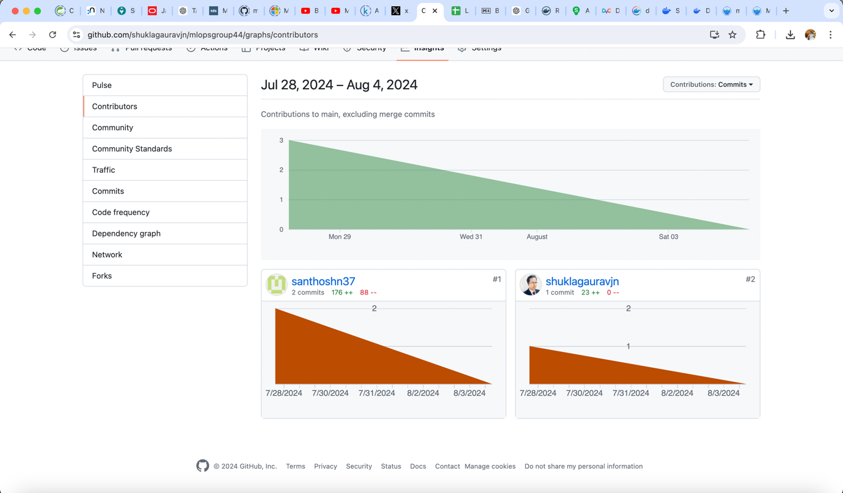

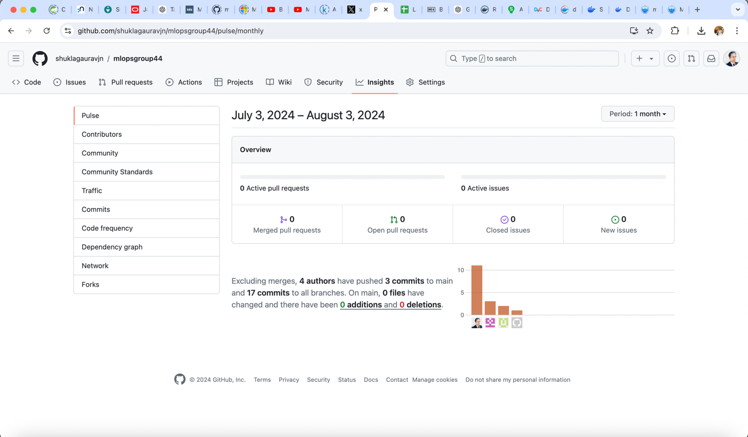

• Demonstrate branching, merging, and pull requests.

Here you can see that there are 3 branches:

1. feature/v0.1
2. main
3. origin/feature/v0.1.1

Team members are contributing to the branches as per their scope of work

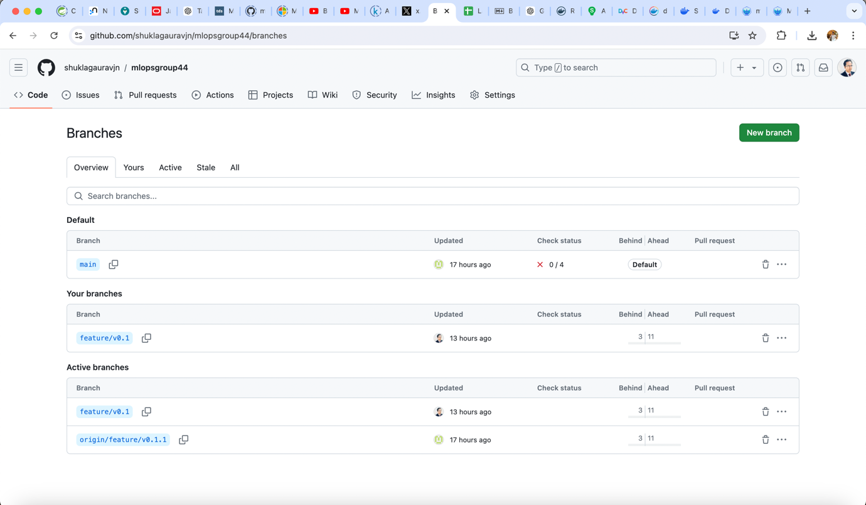

For merging and pull request <Gaurav> to raise PR and ask someone to approve.

**Deliverables**:

• A report detailing the CI/CD pipeline stages.

• Screenshots or logs showing successful runs of the pipeline.

• A Git repository link with branches and merge history.

**M2: Process and Tooling**

**Objective**: Gain hands-on experience with popular MLOps tools and understand the processes they support.

**Tasks**:

1. **Experiment Tracking**:

• Use MLflow to track experiments for a machine learning project.

* ML Flow Screens

1. Do pip install mlflow
2. Execute command mlflow ui

It starts mlflow on the localhost with port 5000.

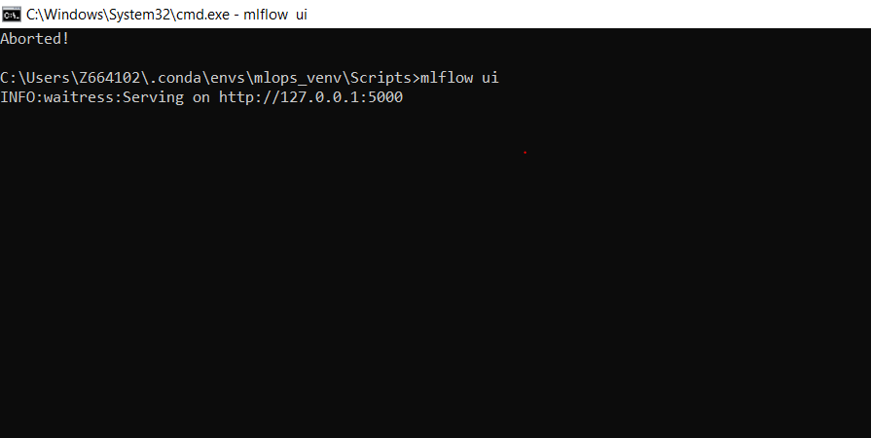

1. In experiments.py file we are setting uri to the localhost with port 5000

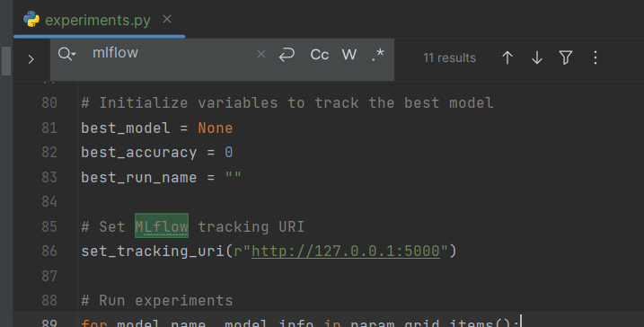

1. We are setting up the attributes for mlflow

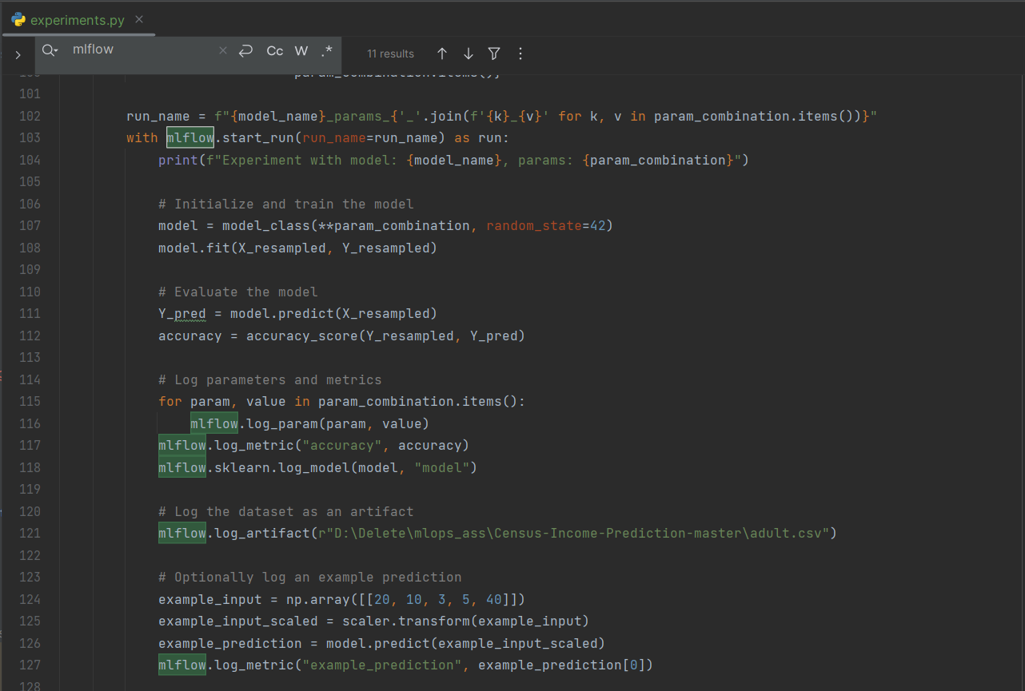

1. We experiments.py is executed, the results and their comparison can be tracked in mlflow ui

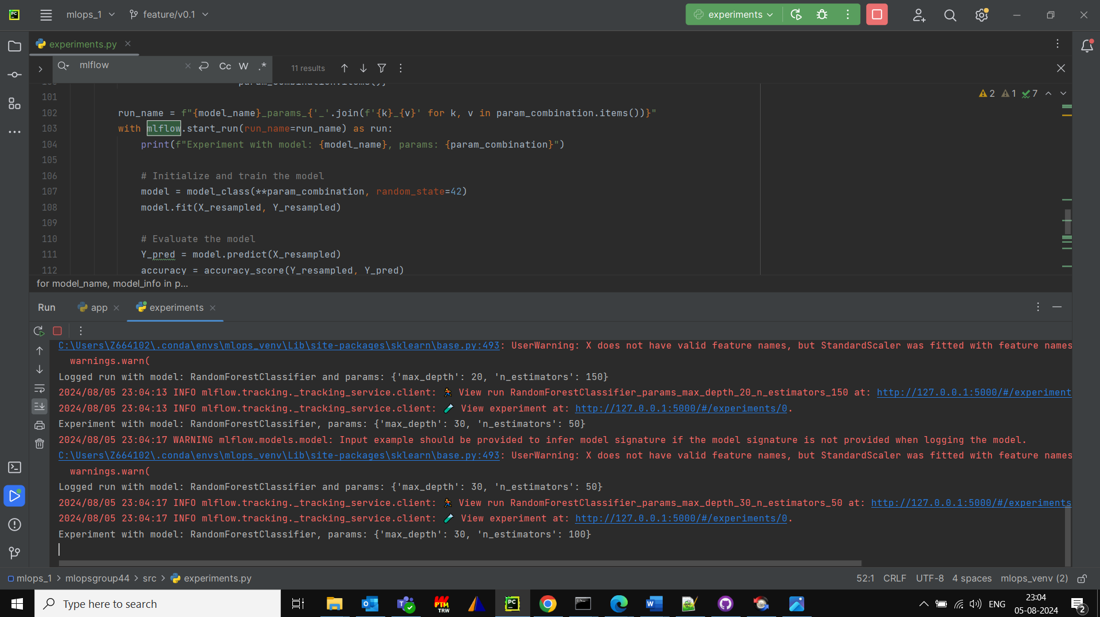

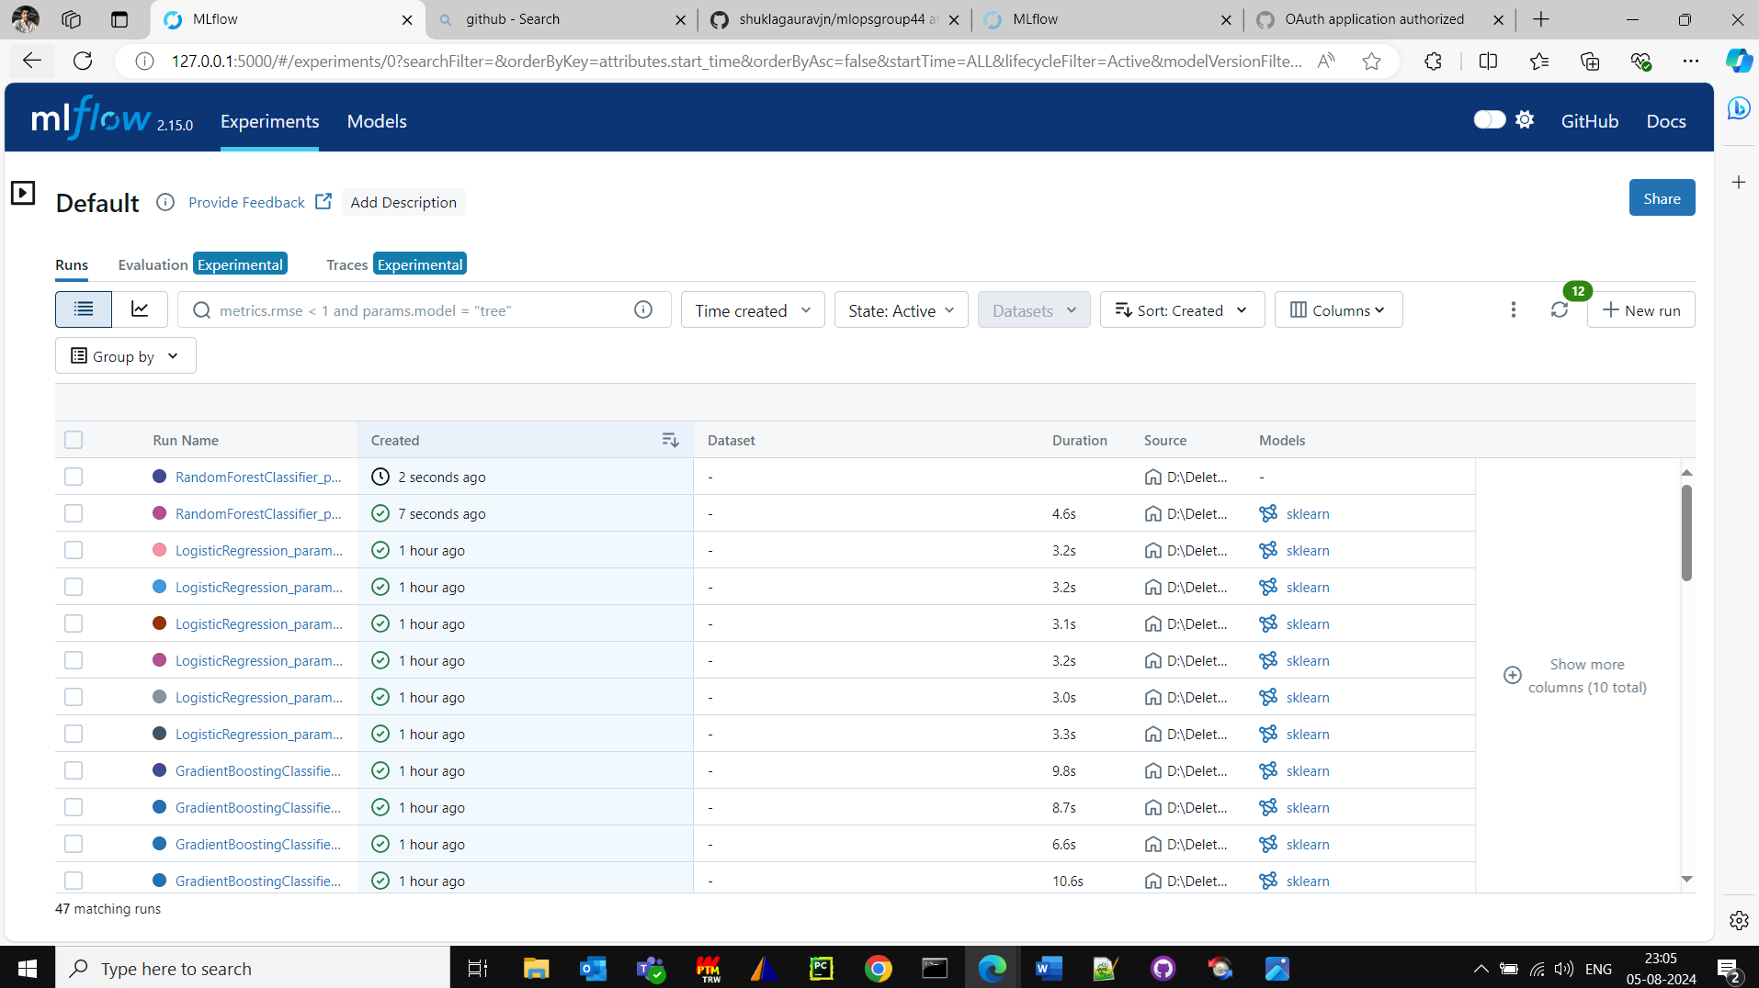

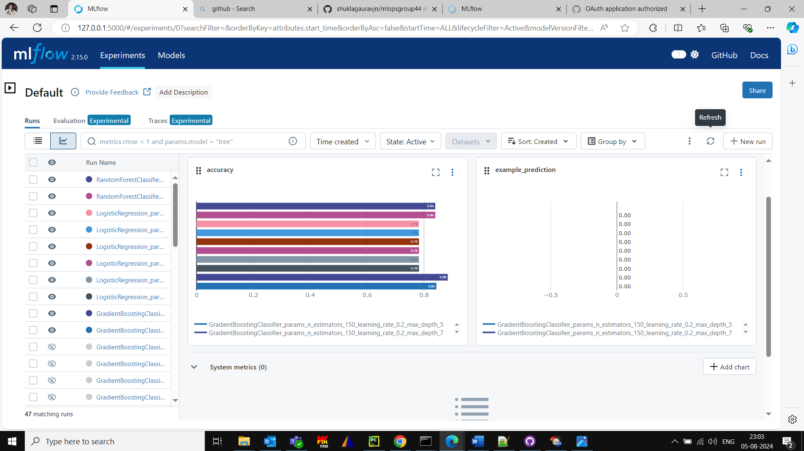

* Please see the screen shot captured from Azure ML studio.

Screen 1:

Here I am using the student subscription for azure and am creating Azure ML Studio:

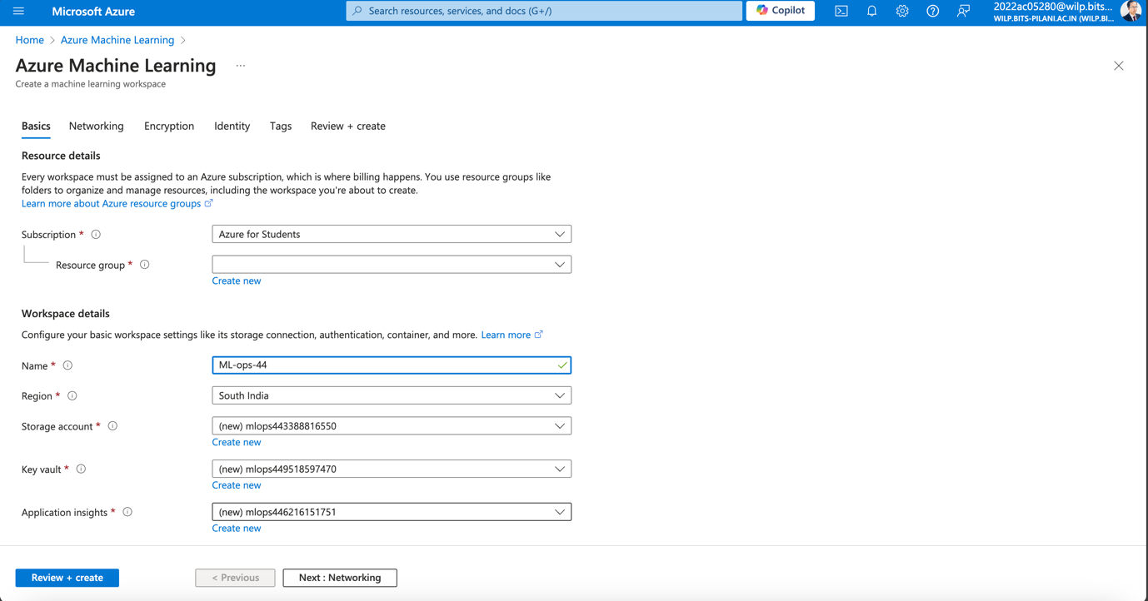

Screen 2: The next screen shows the Azure Machine learning Networking section:

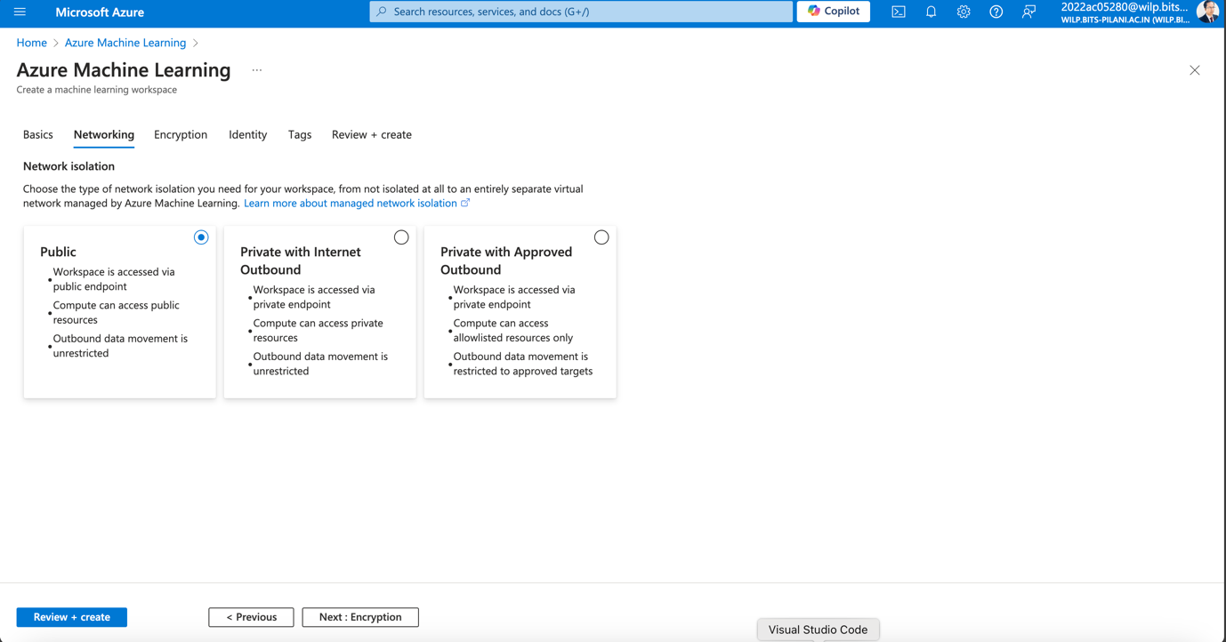

Screen 3: This screen shot shows the encryption of the Azure ML

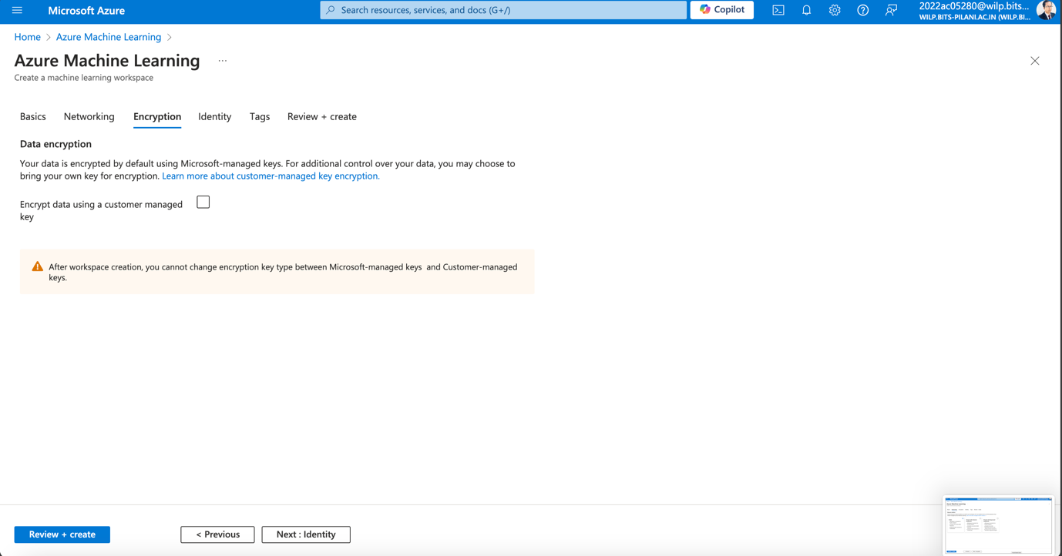

Screen 4: Here we will be referring to the identity of the Azure ML studio

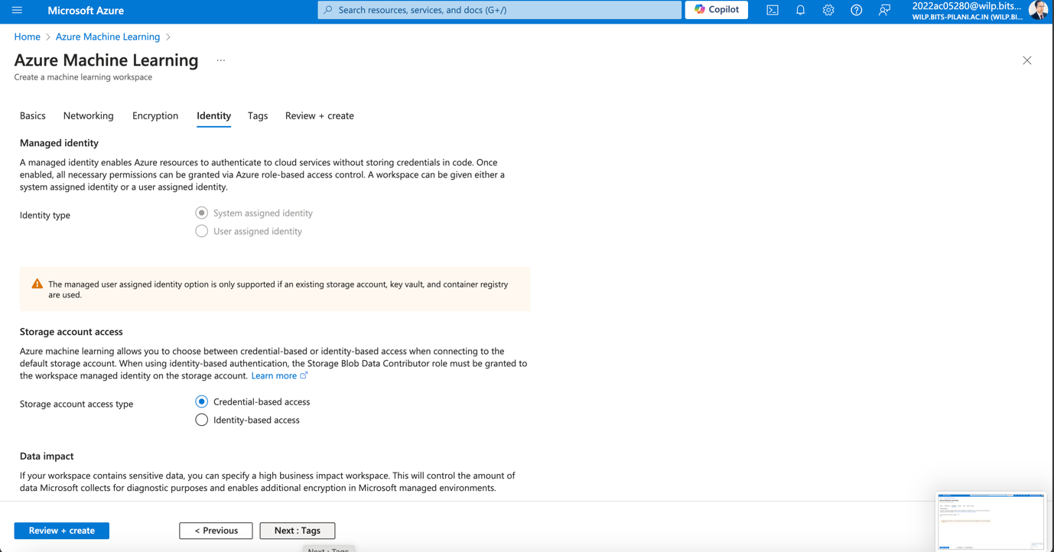

Screen 5: Here we are referring to the tags:

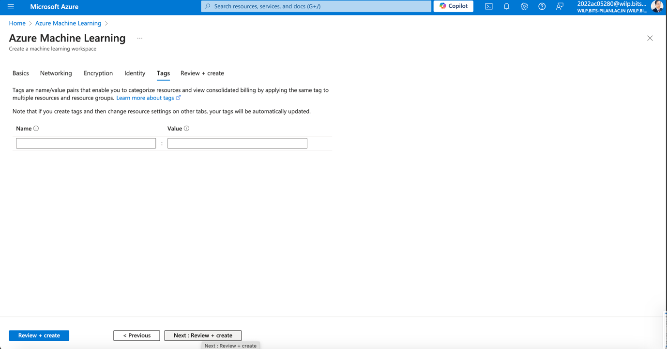

Screen 6: Finally review and create the Azure ML studio

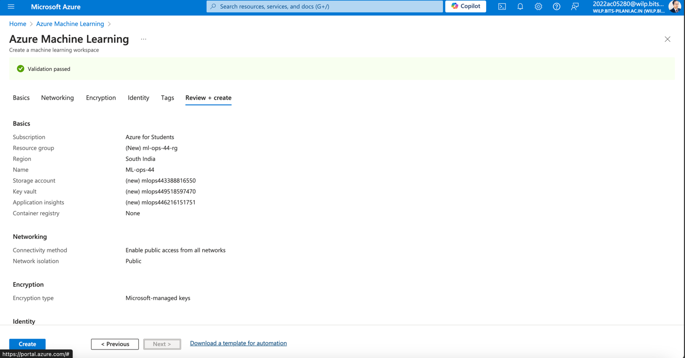

Screen 7: This screen shows the deployment in progress:

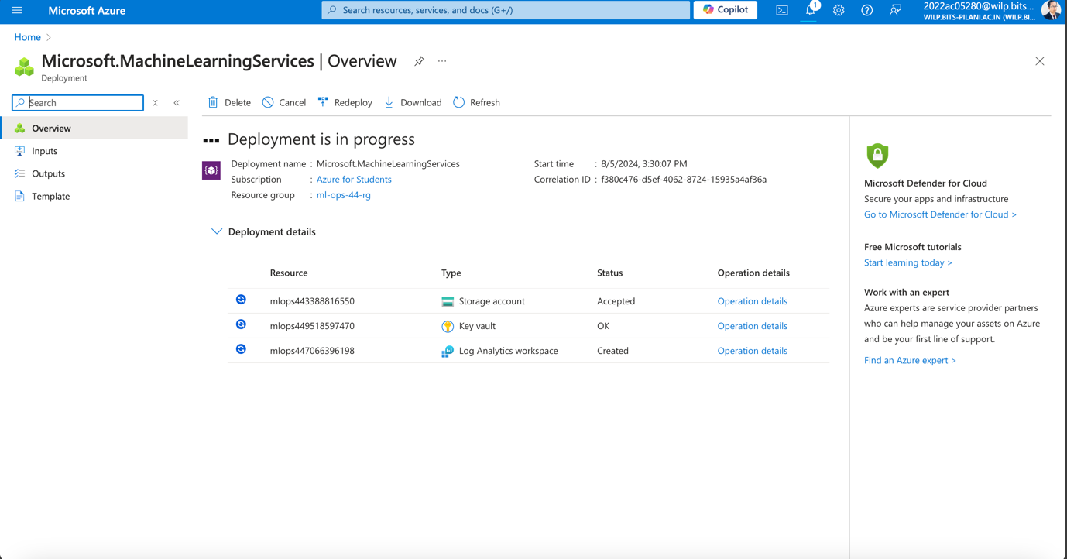

Screen 8: Deployment completed:

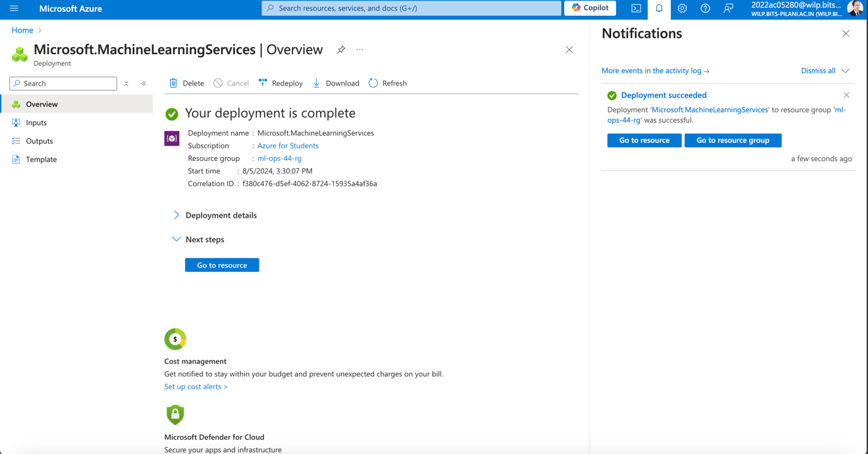

Screen 9: Once the deployment is completed, we can see the Azure ML studio available for use.

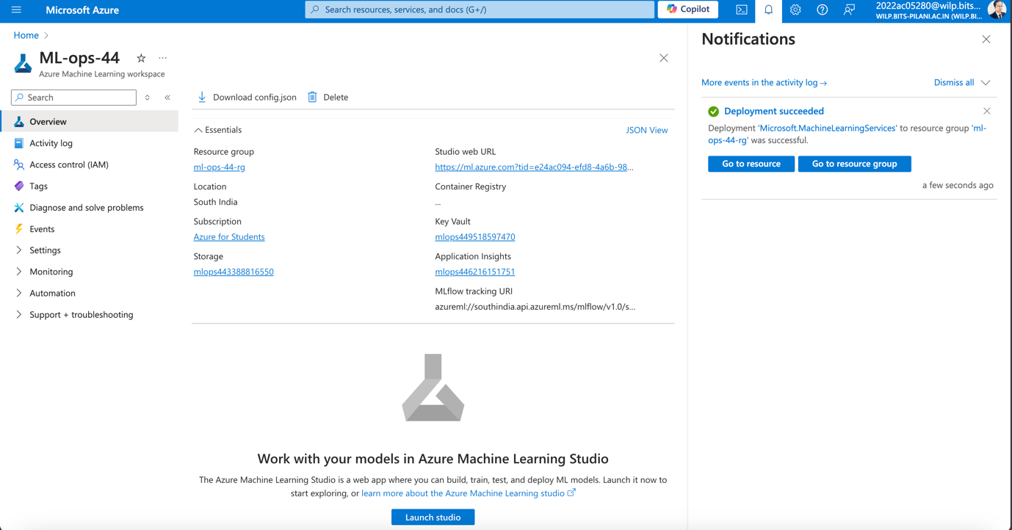

Screen 10: The ML-ops dashboard which is actually Azure Machine learning studio

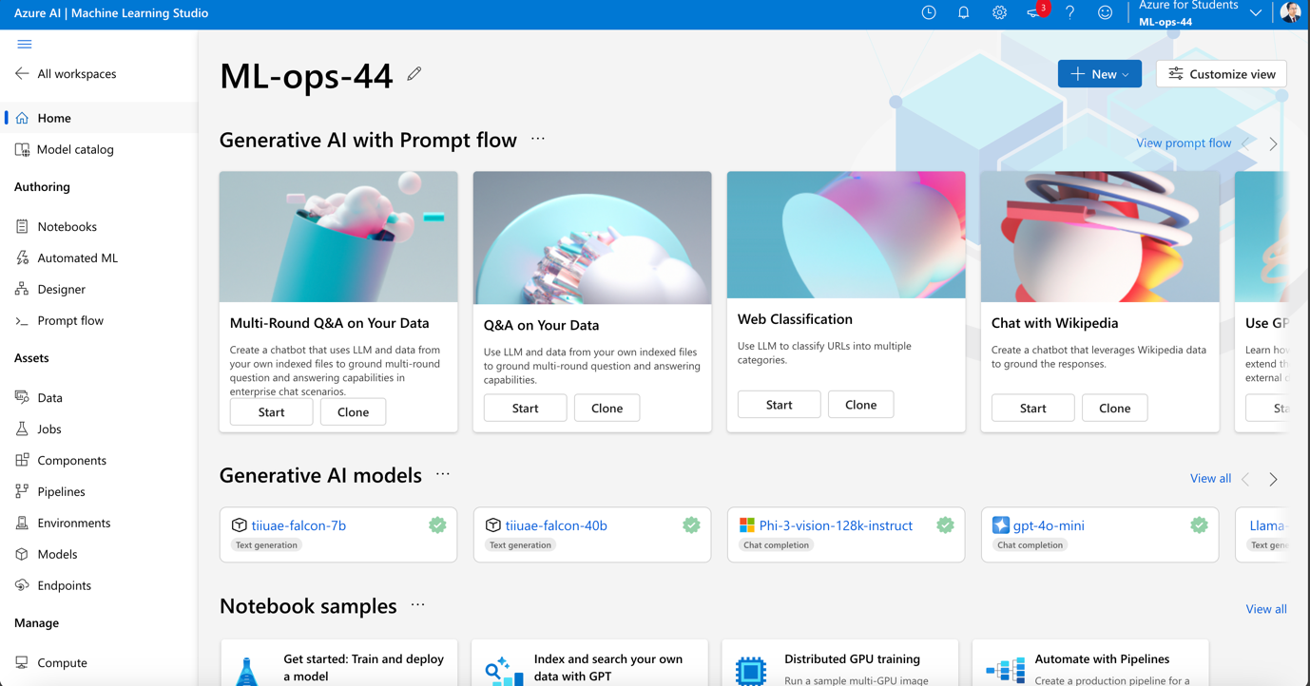

Screen 11: let’s look at the Automated ML of the Machine learning studio

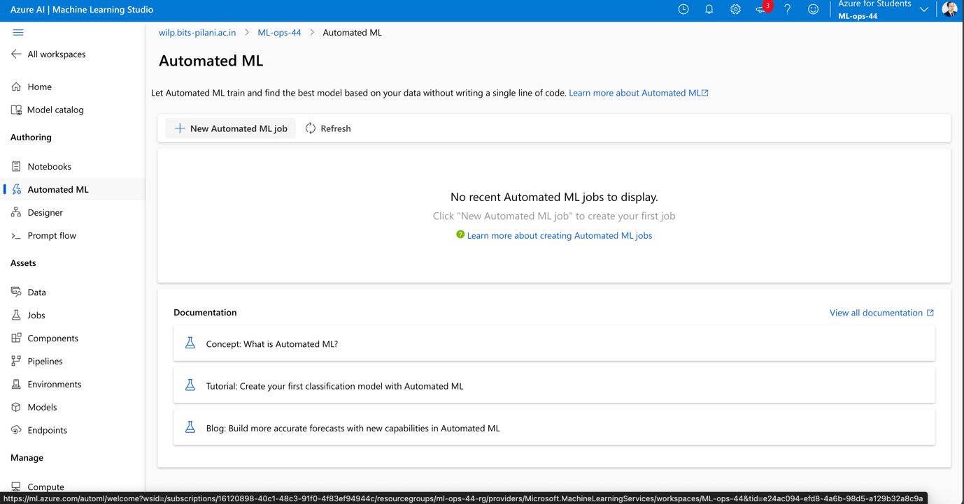

Screen 12: now we are trying to load the adult.csv in machine learning studio

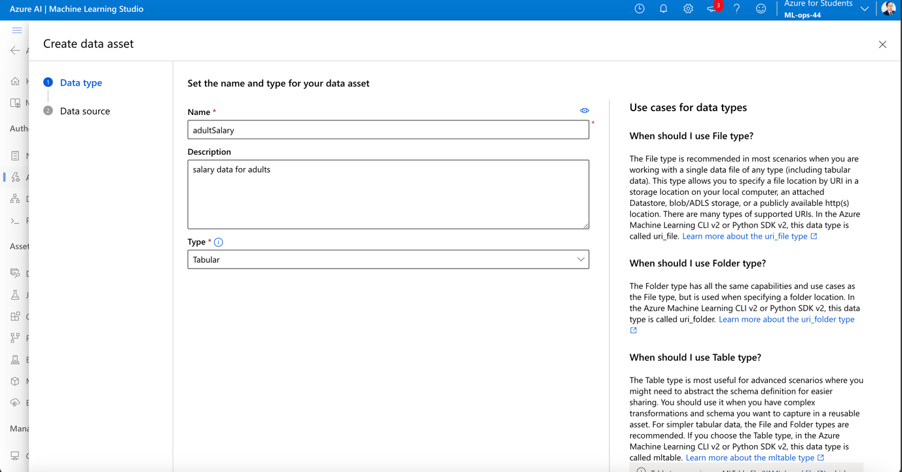

Screen 13: now we are specifying the location of the csv file

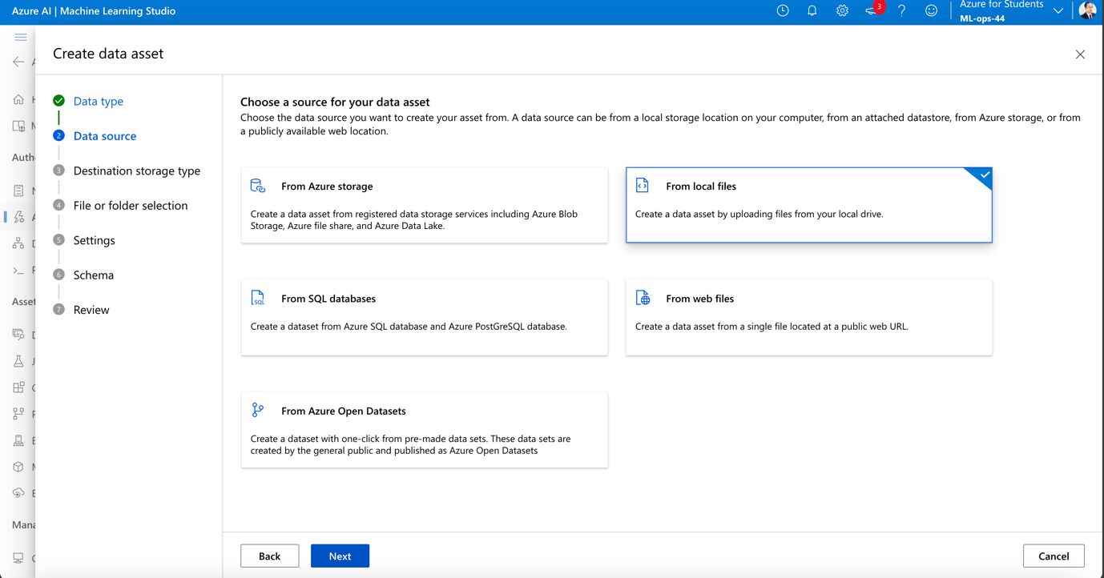

Screen 14: Let’s pick the correct BLOB storage for it.

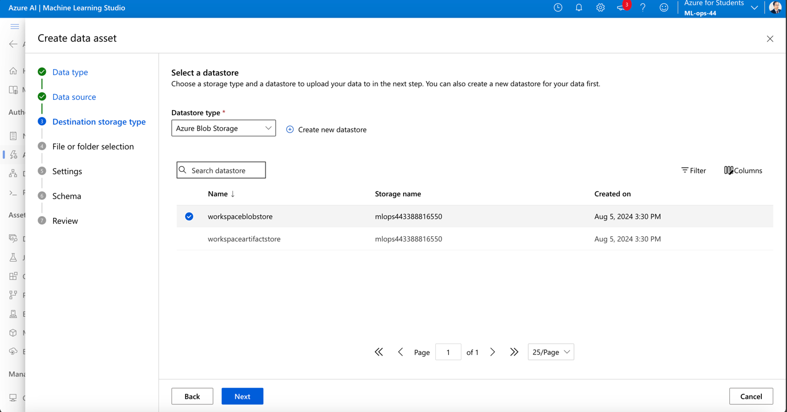

Screen 15: here we select the adult.csv file to be uploaded into the blob storage

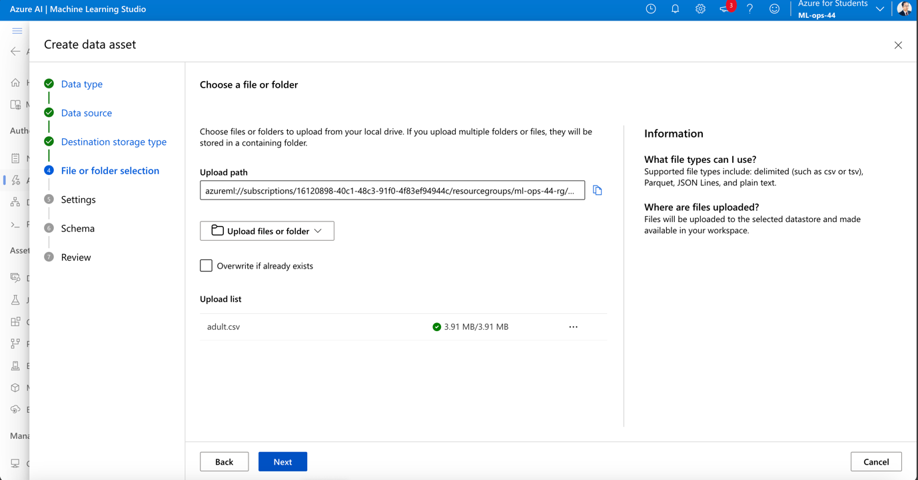

Screen 16: Data of the CSV file is shown below:

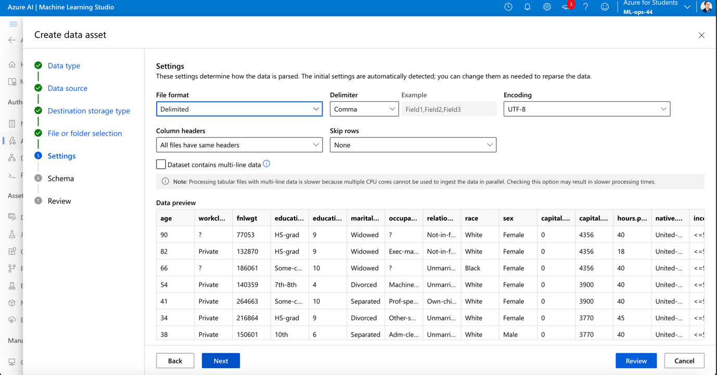

Screen 17: this leads to the deployment of the data and the machine learning model creation next steps.

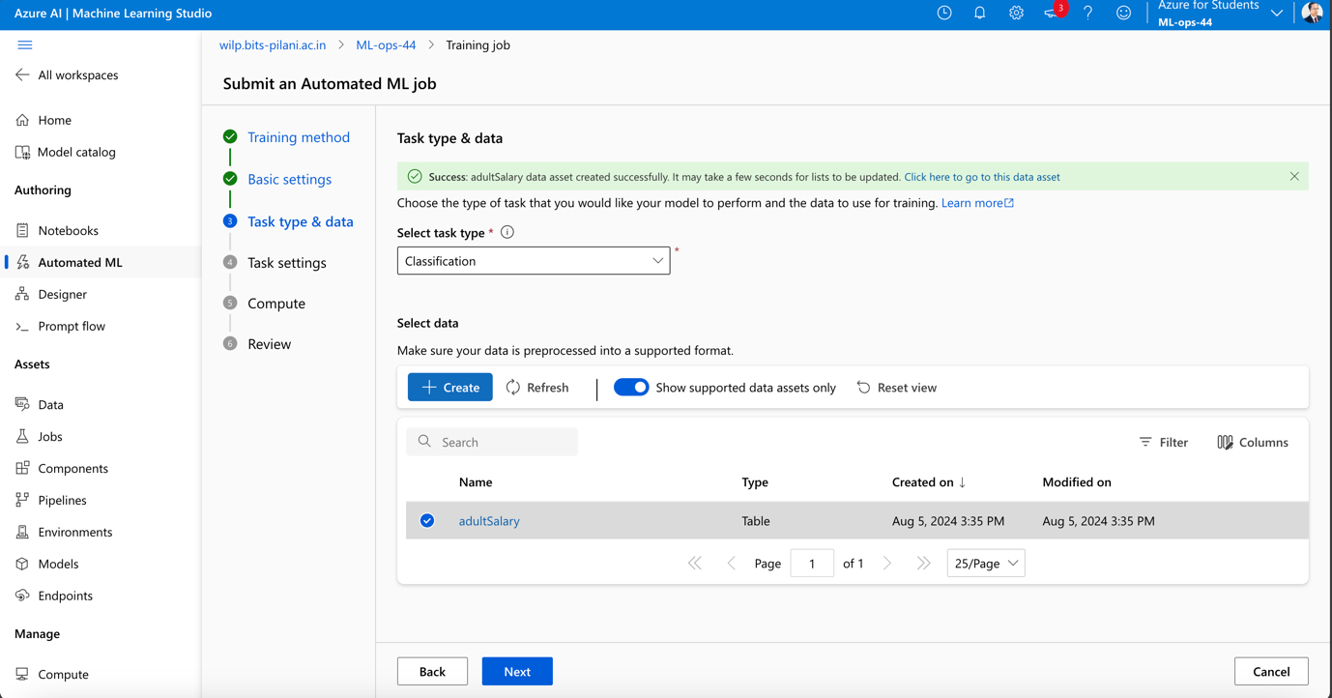

Screen 18: in task setting we specify the train and split option.

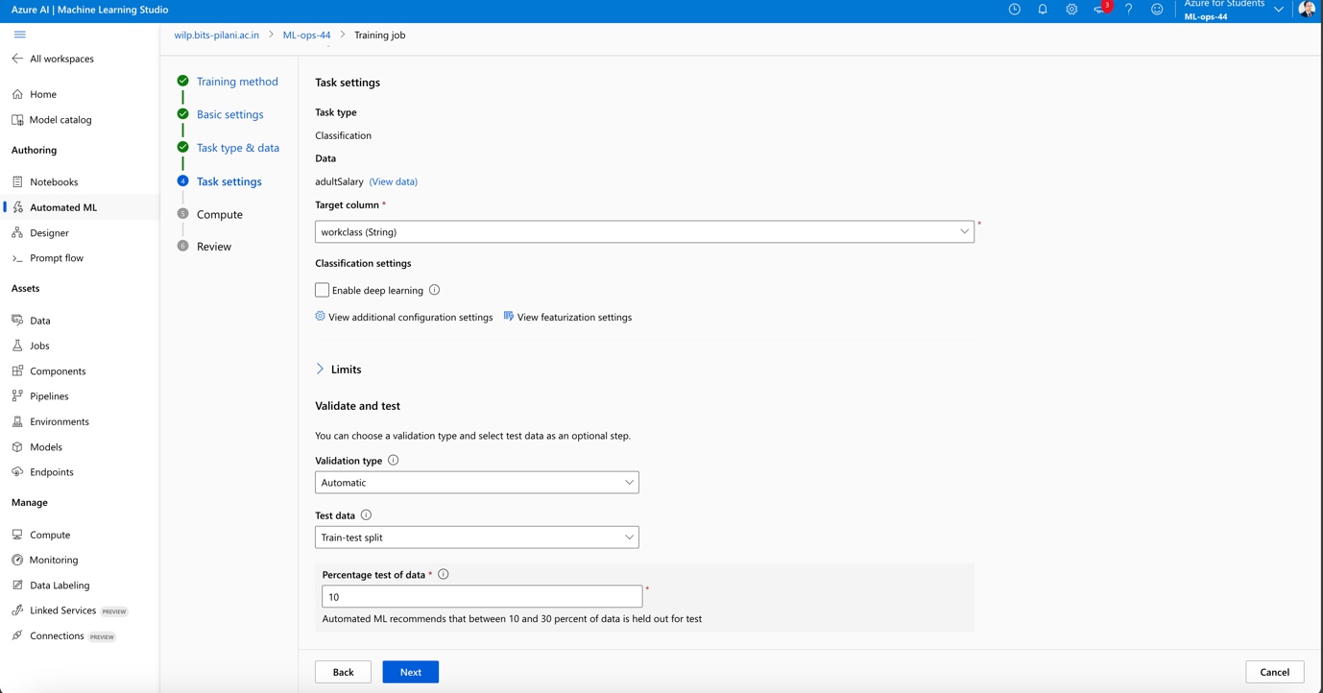

Screen 19: now let’s see the CPU/GPU allocation for the model

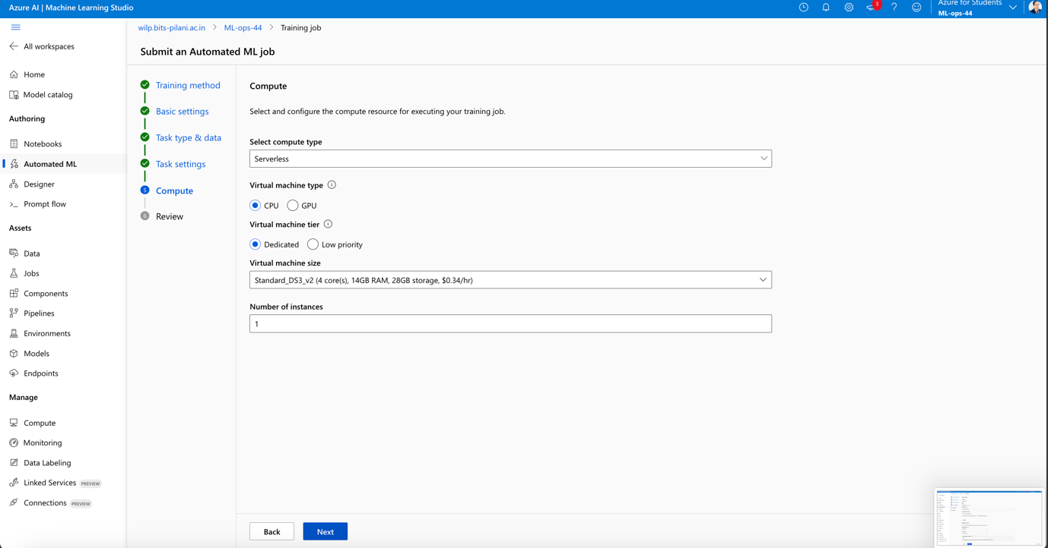

Screen 20: the screen before submitting the job

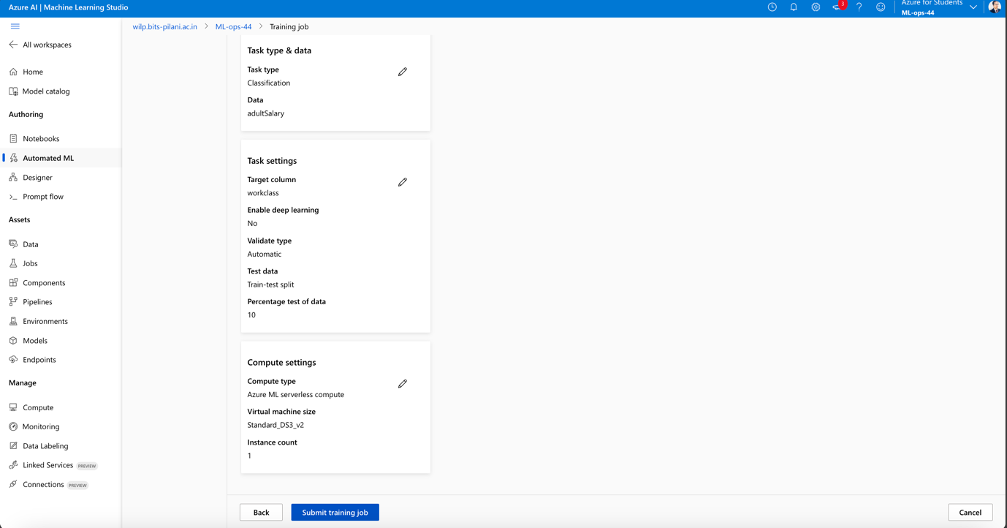

Screen 21: review of the entire machine learning studio

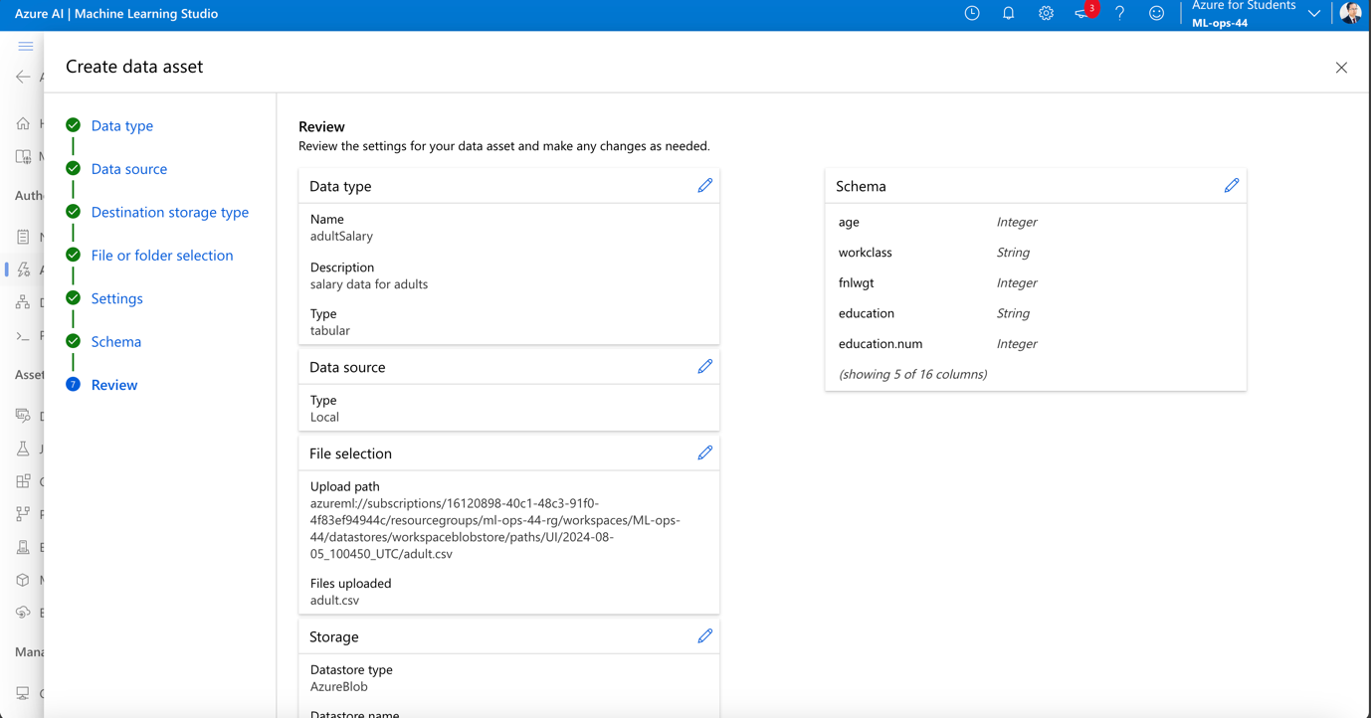

Screen 22: Endpoint creation screen:

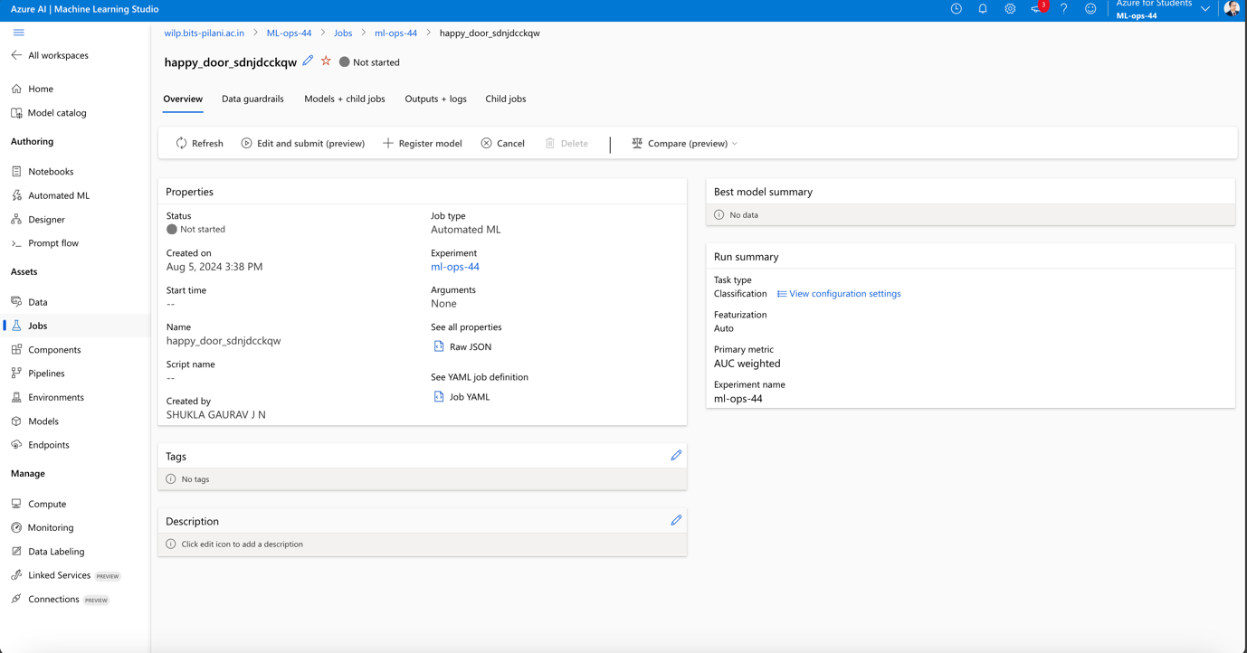

Screen 23: waiting for the model to be ready:

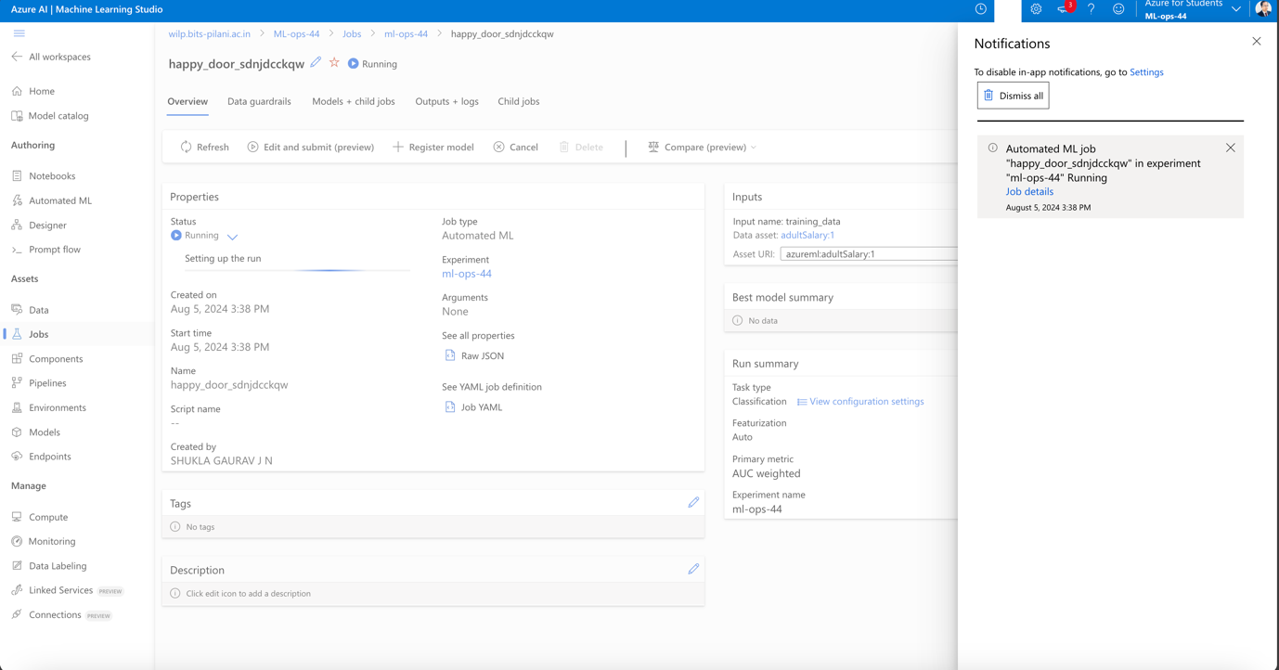

Screen 24: now we can see all the models being run on the data

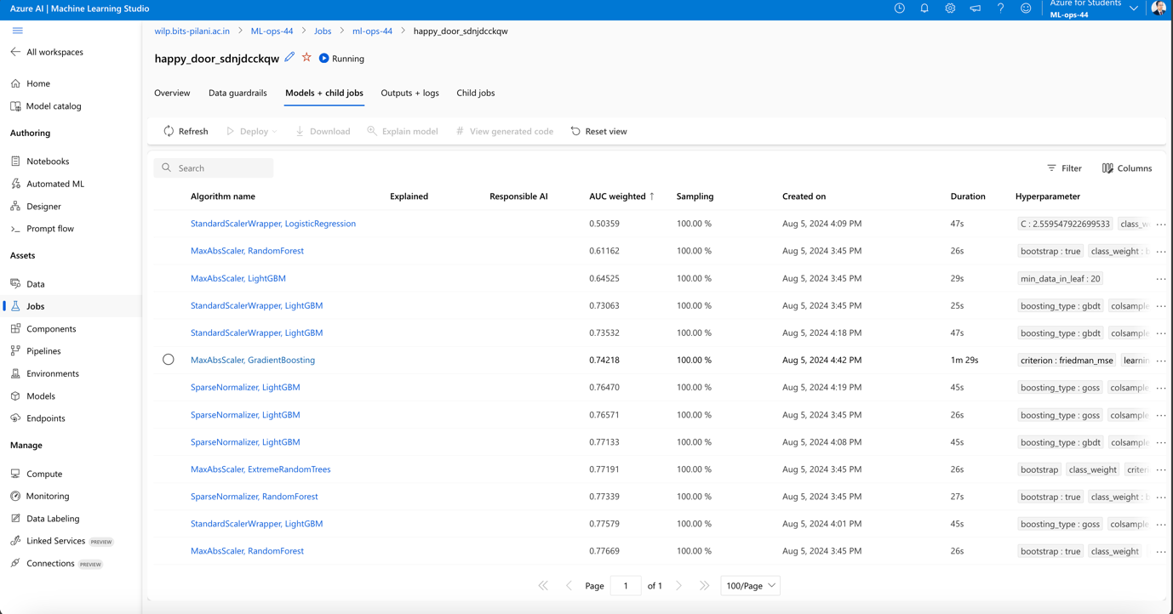

Screen 25:

• Record metrics, parameters, and results of at least three different model training runs.

2. **Data Versioning**:

• Use DVC (Data Version Control) to version control a dataset used in your project.

Please see the screen shot for DVC

Following commands were executed:

Step 1: brew install dvc<br>

Step 2: dvc init <br>

Step 3: git status <br>

Step 4: git commit -m "Initialize DVC" <br>

Step 5: dvc get https://github.com/iterative/dataset-registry \

get-started/data.xml -o data/data.xml <br>

Step 6: dvc add data/data.xml <br>

Step 7: git add data/data.xml.dvc data/.gitignore<br>

Step 8: git commit -m "Add raw data"<br>

Step 9: git add data/data.xml.dvc data/.gitignore<br>

Step 10: mkdir /tmp/dvcstore<br>

Step 11: dvc remote add -d myremote /tmp/dvcstore<br>

Step 12: dvc push<br>

Step 13: dvc pull<br>

Step 14: cp data/data.xml /tmp/data.xml<br>

Step 15: cat /tmp/data.xml >> data/data.xml<br>

Step 16: dvc add data/data.xml

Step 17: dvc push

Step 18: git commit data/data.xml.dvc -m "Dataset updates"

Here is the outcome of these commands:

(myenv) gauravshukla@XMRK9TWQW4WJ python % git init

Reinitialized existing Git repository in /Users/gauravshukla/bits/python/.git/

(myenv) gauravshukla@XMRK9TWQW4WJ python % dvc init

Initialized DVC repository.

You can now commit the changes to git.

+---------------------------------------------------------------------+

| |

| DVC has enabled anonymous aggregate usage analytics. |

| Read the analytics documentation (and how to opt-out) here: |

| <https://dvc.org/doc/user-guide/analytics> |

| |

+---------------------------------------------------------------------+

What's next?

------------

- Check out the documentation: <https://dvc.org/doc>

- Get help and share ideas: <https://dvc.org/chat>

- Star us on GitHub: <https://github.com/iterative/dvc>

(myenv) gauravshukla@XMRK9TWQW4WJ python % git status

On branch feature/v0.1

Your branch is up to date with 'origin/feature/v0.1'.

Untracked files:

(use "git add <file>..." to include in what will be committed)

.DS_Store

data/get-started/

mlopsgroup44/

myenv/

~$signment_Document.docx

nothing added to commit but untracked files present (use "git add" to track)

(myenv) gauravshukla@XMRK9TWQW4WJ python % git commit -m "Initialize DVC"

On branch feature/v0.1

Your branch is up to date with 'origin/feature/v0.1'.

Untracked files:

(use "git add <file>..." to include in what will be committed)

.DS_Store

data/get-started/

mlopsgroup44/

myenv/

~$signment_Document.docx

nothing added to commit but untracked files present (use "git add" to track)

(myenv) gauravshukla@XMRK9TWQW4WJ python % dvc get https://github.com/iterative/dataset-registry \

get-started/data.xml -o data/data.xml

(myenv) gauravshukla@XMRK9TWQW4WJ python % dvc add data/data.xml

100% Adding...|█████████████████████████████████████████████████████████████████████████████████████████████████████████████████████████████████████|1/1 [00:00, 8.03file/s]

To track the changes with git, run:

git add data/.gitignore data/data.xml.dvc

To enable auto staging, run:

dvc config core.autostage true

(myenv) gauravshukla@XMRK9TWQW4WJ python % git add data/data.xml.dvc data/.gitignore

(myenv) gauravshukla@XMRK9TWQW4WJ python % git commit -m "Add raw data"

Auto packing the repository in background for optimum performance.

See "git help gc" for manual housekeeping.

[feature/v0.1 c616cc5] Add raw data

2 files changed, 6 insertions(+)

create mode 100644 data/.gitignore

create mode 100644 data/data.xml.dvc

(myenv) gauravshukla@XMRK9TWQW4WJ python % mkdir /tmp/dvcstore

(myenv) gauravshukla@XMRK9TWQW4WJ python % dvc remote add -d myremote /tmp/dvcstore

Setting 'myremote' as a default remote.

(myenv) gauravshukla@XMRK9TWQW4WJ python % dvc remote add -d storage s3://mybucket/dvcstore

Setting 'storage' as a default remote.

(myenv) gauravshukla@XMRK9TWQW4WJ python % dvc push

Collecting |1.00 [00:00, 530entry/s]

Pushing

ERROR: unexpected error - Unable to locate credentials

Having any troubles? Hit us up at https://dvc.org/support, we are always happy to help!

(myenv) gauravshukla@XMRK9TWQW4WJ python % ls

Assignment_Document.docx ci-cd-pipeline.yml models requirements.txt

Dockerfile data myenv src

README.md mlopsgroup44 notebooks ~$signment_Document.docx

(myenv) gauravshukla@XMRK9TWQW4WJ python % ls -all

total 7056

drwxr-xr-x 19 gauravshukla staff 608 Aug 5 12:59 .

drwxr-xr-x 6 gauravshukla staff 192 Aug 5 11:40 ..

-rw-r--r--@ 1 gauravshukla staff 8196 Aug 5 11:17 .DS_Store

drwxr-xr-x@ 6 gauravshukla staff 192 Aug 5 13:00 .dvc

-rw-r--r--@ 1 gauravshukla staff 139 Aug 5 12:59 .dvcignore

drwxr-xr-x@ 15 gauravshukla staff 480 Aug 5 13:01 .git

drwxr-xr-x@ 3 gauravshukla staff 96 Aug 1 17:28 .github

-rw-r--r--@ 1 gauravshukla staff 3574304 Aug 4 11:26 Assignment_Document.docx

-rw-r--r--@ 1 gauravshukla staff 494 Aug 3 18:03 Dockerfile

-rw-r--r--@ 1 gauravshukla staff 2568 Aug 4 11:28 README.md

-rw-r--r--@ 1 gauravshukla staff 878 Aug 3 16:56 ci-cd-pipeline.yml

drwxr-xr-x 7 gauravshukla staff 224 Aug 5 13:00 data

drwxr-xr-x@ 5 gauravshukla staff 160 Jul 31 16:37 mlopsgroup44

drwxr-xr-x 2 gauravshukla staff 64 Jul 31 19:53 models

drwxr-xr-x 8 gauravshukla staff 256 Jul 31 18:50 myenv

drwxr-xr-x 2 gauravshukla staff 64 Jul 31 19:53 notebooks

-rw-r--r--@ 1 gauravshukla staff 36 Jul 31 18:42 requirements.txt

drwxr-xr-x 3 gauravshukla staff 96 Jul 31 19:53 src

-rw-r--r--@ 1 gauravshukla staff 162 Aug 4 21:32 ~$signment_Document.docx

(myenv) gauravshukla@XMRK9TWQW4WJ python % mkdir tmp

(myenv) gauravshukla@XMRK9TWQW4WJ python % ls -all

total 7056

drwxr-xr-x 20 gauravshukla staff 640 Aug 5 14:14 .

drwxr-xr-x 6 gauravshukla staff 192 Aug 5 11:40 ..

-rw-r--r--@ 1 gauravshukla staff 8196 Aug 5 11:17 .DS_Store

drwxr-xr-x@ 6 gauravshukla staff 192 Aug 5 13:00 .dvc

-rw-r--r--@ 1 gauravshukla staff 139 Aug 5 12:59 .dvcignore

drwxr-xr-x@ 15 gauravshukla staff 480 Aug 5 13:01 .git

drwxr-xr-x@ 3 gauravshukla staff 96 Aug 1 17:28 .github

-rw-r--r--@ 1 gauravshukla staff 3574304 Aug 4 11:26 Assignment_Document.docx

-rw-r--r--@ 1 gauravshukla staff 494 Aug 3 18:03 Dockerfile

-rw-r--r--@ 1 gauravshukla staff 2568 Aug 4 11:28 README.md

-rw-r--r--@ 1 gauravshukla staff 878 Aug 3 16:56 ci-cd-pipeline.yml

drwxr-xr-x 7 gauravshukla staff 224 Aug 5 13:00 data

drwxr-xr-x@ 5 gauravshukla staff 160 Jul 31 16:37 mlopsgroup44

drwxr-xr-x 2 gauravshukla staff 64 Jul 31 19:53 models

drwxr-xr-x 8 gauravshukla staff 256 Jul 31 18:50 myenv

drwxr-xr-x 2 gauravshukla staff 64 Jul 31 19:53 notebooks

-rw-r--r--@ 1 gauravshukla staff 36 Jul 31 18:42 requirements.txt

drwxr-xr-x 3 gauravshukla staff 96 Jul 31 19:53 src

drwxr-xr-x@ 2 gauravshukla staff 64 Aug 5 14:14 tmp

-rw-r--r--@ 1 gauravshukla staff 162 Aug 4 21:32 ~$signment_Document.docx

(myenv) gauravshukla@XMRK9TWQW4WJ python % cd tmp

(myenv) gauravshukla@XMRK9TWQW4WJ tmp % mkdir dvcstore

(myenv) gauravshukla@XMRK9TWQW4WJ tmp % ls

dvcstore

(myenv) gauravshukla@XMRK9TWQW4WJ tmp % cd ..

(myenv) gauravshukla@XMRK9TWQW4WJ python % ls -all

total 7056

drwxr-xr-x 20 gauravshukla staff 640 Aug 5 14:14 .

drwxr-xr-x 6 gauravshukla staff 192 Aug 5 11:40 ..

-rw-r--r--@ 1 gauravshukla staff 8196 Aug 5 11:17 .DS_Store

drwxr-xr-x@ 6 gauravshukla staff 192 Aug 5 13:00 .dvc

-rw-r--r--@ 1 gauravshukla staff 139 Aug 5 12:59 .dvcignore

drwxr-xr-x@ 15 gauravshukla staff 480 Aug 5 13:01 .git

drwxr-xr-x@ 3 gauravshukla staff 96 Aug 1 17:28 .github

-rw-r--r--@ 1 gauravshukla staff 3574304 Aug 4 11:26 Assignment_Document.docx

-rw-r--r--@ 1 gauravshukla staff 494 Aug 3 18:03 Dockerfile

-rw-r--r--@ 1 gauravshukla staff 2568 Aug 4 11:28 README.md

-rw-r--r--@ 1 gauravshukla staff 878 Aug 3 16:56 ci-cd-pipeline.yml

drwxr-xr-x 7 gauravshukla staff 224 Aug 5 13:00 data

drwxr-xr-x@ 5 gauravshukla staff 160 Jul 31 16:37 mlopsgroup44

drwxr-xr-x 2 gauravshukla staff 64 Jul 31 19:53 models

drwxr-xr-x 8 gauravshukla staff 256 Jul 31 18:50 myenv

drwxr-xr-x 2 gauravshukla staff 64 Jul 31 19:53 notebooks

-rw-r--r--@ 1 gauravshukla staff 36 Jul 31 18:42 requirements.txt

drwxr-xr-x 3 gauravshukla staff 96 Jul 31 19:53 src

drwxr-xr-x@ 3 gauravshukla staff 96 Aug 5 14:15 tmp

-rw-r--r--@ 1 gauravshukla staff 162 Aug 4 21:32 ~$signment_Document.docx

(myenv) gauravshukla@XMRK9TWQW4WJ python % git add data/data.xml.dvc data/.gitignore

(myenv) gauravshukla@XMRK9TWQW4WJ python % git commit -m "Add raw data"

On branch feature/v0.1

Your branch is ahead of 'origin/feature/v0.1' by 1 commit.

(use "git push" to publish your local commits)

Changes not staged for commit:

(use "git add <file>..." to update what will be committed)

(use "git restore <file>..." to discard changes in working directory)

modified: .dvc/config

Untracked files:

(use "git add <file>..." to include in what will be committed)

.DS_Store

data/get-started/

mlopsgroup44/

myenv/

~$signment_Document.docx

no changes added to commit (use "git add" and/or "git commit -a")

(myenv) gauravshukla@XMRK9TWQW4WJ python % dvc remote add -d myremote /tmp/dvcstore

Setting 'myremote' as a default remote.

ERROR: configuration error - config file error: remote 'myremote' already exists. Use `-f|--force` to overwrite it.

(myenv) gauravshukla@XMRK9TWQW4WJ python % pwd

/Users/gauravshukla/bits/python

(myenv) gauravshukla@XMRK9TWQW4WJ python % vi .dvc/config

(myenv) gauravshukla@XMRK9TWQW4WJ python % ls -all

total 7056

drwxr-xr-x 20 gauravshukla staff 640 Aug 5 14:14 .

drwxr-xr-x 6 gauravshukla staff 192 Aug 5 11:40 ..

-rw-r--r--@ 1 gauravshukla staff 8196 Aug 5 11:17 .DS_Store

drwxr-xr-x@ 6 gauravshukla staff 192 Aug 5 14:28 .dvc

-rw-r--r--@ 1 gauravshukla staff 139 Aug 5 12:59 .dvcignore

drwxr-xr-x@ 15 gauravshukla staff 480 Aug 5 14:16 .git

drwxr-xr-x@ 3 gauravshukla staff 96 Aug 1 17:28 .github

-rw-r--r--@ 1 gauravshukla staff 3574304 Aug 4 11:26 Assignment_Document.docx

-rw-r--r--@ 1 gauravshukla staff 494 Aug 3 18:03 Dockerfile

-rw-r--r--@ 1 gauravshukla staff 2568 Aug 4 11:28 README.md

-rw-r--r--@ 1 gauravshukla staff 878 Aug 3 16:56 ci-cd-pipeline.yml

drwxr-xr-x 7 gauravshukla staff 224 Aug 5 13:00 data

drwxr-xr-x@ 5 gauravshukla staff 160 Jul 31 16:37 mlopsgroup44

drwxr-xr-x 2 gauravshukla staff 64 Jul 31 19:53 models

drwxr-xr-x 8 gauravshukla staff 256 Jul 31 18:50 myenv

drwxr-xr-x 2 gauravshukla staff 64 Jul 31 19:53 notebooks

-rw-r--r--@ 1 gauravshukla staff 36 Jul 31 18:42 requirements.txt

drwxr-xr-x 3 gauravshukla staff 96 Jul 31 19:53 src

drwxr-xr-x@ 3 gauravshukla staff 96 Aug 5 14:15 tmp

-rw-r--r--@ 1 gauravshukla staff 162 Aug 4 21:32 ~$signment_Document.docx

(myenv) gauravshukla@XMRK9TWQW4WJ python % cd tmp

(myenv) gauravshukla@XMRK9TWQW4WJ tmp % ls

dvcstore

(myenv) gauravshukla@XMRK9TWQW4WJ tmp % cd ..

(myenv) gauravshukla@XMRK9TWQW4WJ python % dvc push

Collecting |0.00 [00:00, ?entry/s]

Pushing

ERROR: unexpected error - Unable to locate credentials

Having any troubles? Hit us up at https://dvc.org/support, we are always happy to help!

(myenv) gauravshukla@XMRK9TWQW4WJ python % vi .dvc/config

(myenv) gauravshukla@XMRK9TWQW4WJ python % dvc push

ERROR: failed to push data to the cloud - config file error: remote 'storage' doesn't exist

(myenv) gauravshukla@XMRK9TWQW4WJ python % vi .dvc/config

(myenv) gauravshukla@XMRK9TWQW4WJ python % vi .dvc/config

(myenv) gauravshukla@XMRK9TWQW4WJ python % dvc push

Collecting |0.00 [00:00, ?entry/s]

Pushing

ERROR: failed to push data to the cloud - config file error: no remote specified in /Users/gauravshukla/bits/python. Setup default remote with

dvc remote default <remote name>

or use:

dvc <command> -r <remote name>

(myenv) gauravshukla@XMRK9TWQW4WJ python % vi .dvc/config

(myenv) gauravshukla@XMRK9TWQW4WJ python % dvc remote default myremote

(myenv) gauravshukla@XMRK9TWQW4WJ python % dvc push

Collecting |1.00 [00:00, 537entry/s]

Pushing

1 file pushed

(myenv) gauravshukla@XMRK9TWQW4WJ python % dvc pull

Collecting |1.00 [00:00, 724entry/s]

Fetching

Building workspace index |2.00 [00:00, 238entry/s]

Comparing indexes |3.00 [00:00, 2.83kentry/s]

Applying changes |0.00 [00:00, ?file/s]

Everything is up to date.

(myenv) gauravshukla@XMRK9TWQW4WJ python % cp data/data.xml /tmp/data.xml

(myenv) gauravshukla@XMRK9TWQW4WJ python % cat /tmp/data.xml >> data/data.xml

(myenv) gauravshukla@XMRK9TWQW4WJ python % vi /tmp/data.xml

(myenv) gauravshukla@XMRK9TWQW4WJ python % dvc add data/data.xml

100% Adding...|█████████████████████████████████████████████████████████████████████████████████████████████████████████████████████████████████████|1/1 [00:00, 8.01file/s]

To track the changes with git, run:

git add data/data.xml.dvc

To enable auto staging, run:

dvc config core.autostage true

(myenv) gauravshukla@XMRK9TWQW4WJ python % dvc push

Collecting |1.00 [00:00, 777entry/s]

Pushing

1 file pushed

(myenv) gauravshukla@XMRK9TWQW4WJ python % git commit data/data.xml.dvc -m "Dataset updates"

Auto packing the repository in background for optimum performance.

See "git help gc" for manual housekeeping.

warning: The last gc run reported the following. Please correct the root cause

and remove .git/gc.log

Automatic cleanup will not be performed until the file is removed.

warning: There are too many unreachable loose objects; run 'git prune' to remove them.

[feature/v0.1 2fc60f9] Dataset updates

1 file changed, 2 insertions(+), 2 deletions(-)

(myenv) gauravshukla@XMRK9TWQW4WJ python % git status

On branch feature/v0.1

Your branch is ahead of 'origin/feature/v0.1' by 2 commits.

(use "git push" to publish your local commits)

Changes not staged for commit:

(use "git add <file>..." to update what will be committed)

(use "git restore <file>..." to discard changes in working directory)

modified: .dvc/config

modified: README.md

Untracked files:

(use "git add <file>..." to include in what will be committed)

.DS_Store

data/get-started/

mlopsgroup44/

myenv/

tmp/

~$signment_Document.docx

no changes added to commit (use "git add" and/or "git commit -a")

(myenv) gauravshukla@XMRK9TWQW4WJ python % git add .dvc/config README.md data/get-started/ tmp/

(myenv) gauravshukla@XMRK9TWQW4WJ python % git commit -m "dvc changes"

Auto packing the repository in background for optimum performance.

See "git help gc" for manual housekeeping.

warning: The last gc run reported the following. Please correct the root cause

and remove .git/gc.log

Automatic cleanup will not be performed until the file is removed.

warning: There are too many unreachable loose objects; run 'git prune' to remove them.

[feature/v0.1 c642a2b] dvc changes

4 files changed, 24 insertions(+), 7 deletions(-)

create mode 100644 data/get-started/.gitignore

create mode 100644 tmp/.DS_Store

(myenv) gauravshukla@XMRK9TWQW4WJ python % git push

Enumerating objects: 23, done.

Counting objects: 100% (23/23), done.

Delta compression using up to 10 threads

Compressing objects: 100% (15/15), done.

Writing objects: 100% (18/18), 1.99 KiB | 203.00 KiB/s, done.

Total 18 (delta 6), reused 3 (delta 0), pack-reused 0

remote: Resolving deltas: 100% (6/6), completed with 2 local objects.

To github.com:shuklagauravjn/mlopsgroup44

ad517da..c642a2b feature/v0.1 -> feature/v0.1

(myenv) gauravshukla@XMRK9TWQW4WJ python %

• Show how to revert to a previous version of the dataset.

Switching between versions

git checkout <...>

$ **dvc checkout**

Return to a previous version of the dataset

git checkout HEAD~1 data/data.xml.dvc

$ **dvc checkout**

git commit data/data.xml.dvc -m "Revert dataset updates"

**Deliverables**:

• MLflow experiment logs with different runs and their results.

• A DVC repository showing different versions of the dataset.

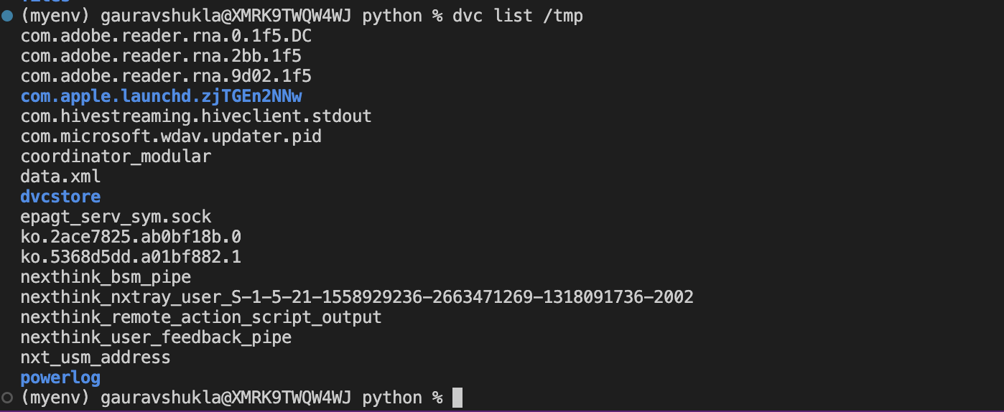

**M3: Model Experimentation and Packaging**

**Objective**: Train a machine learning model, perform hyperparameter tuning, and package the model for deployment.

**Tasks**:

1. **Hyperparameter Tuning**:

• Use a library like Optuna or Scikit-learn’s GridSearchCV to perform hyperparameter tuning on a chosen model.

• Document the tuning process and the best parameters found.

Define the parameter grid and generating all possible combinations

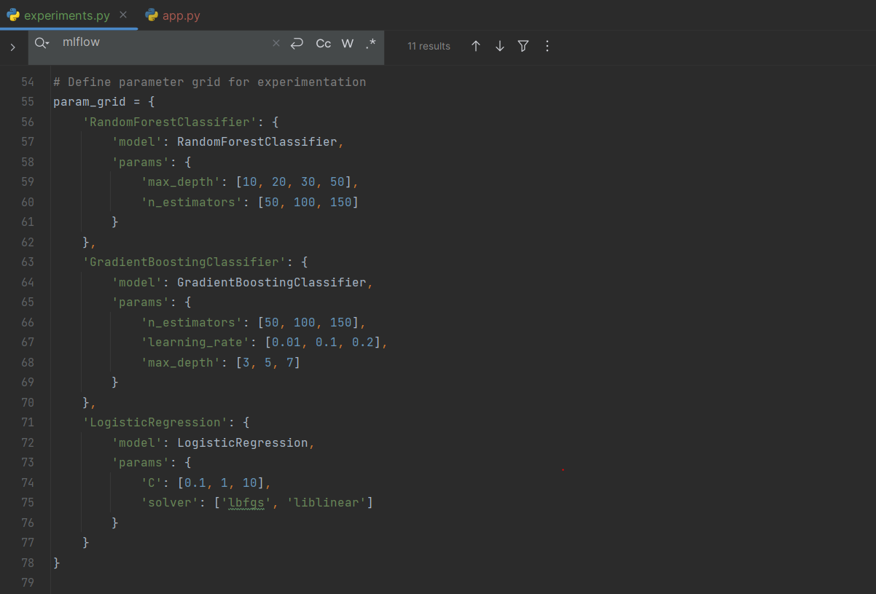

Training and evaluating the models

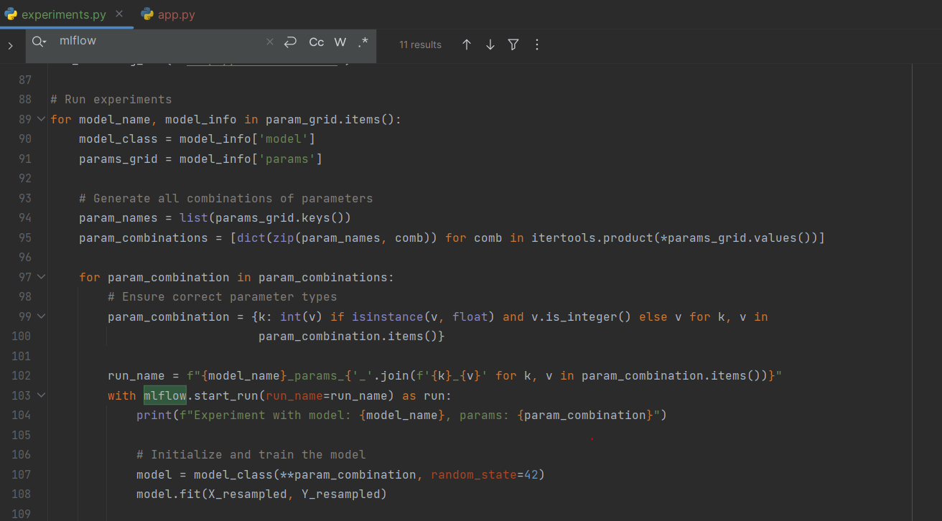

Logging and saving the best model

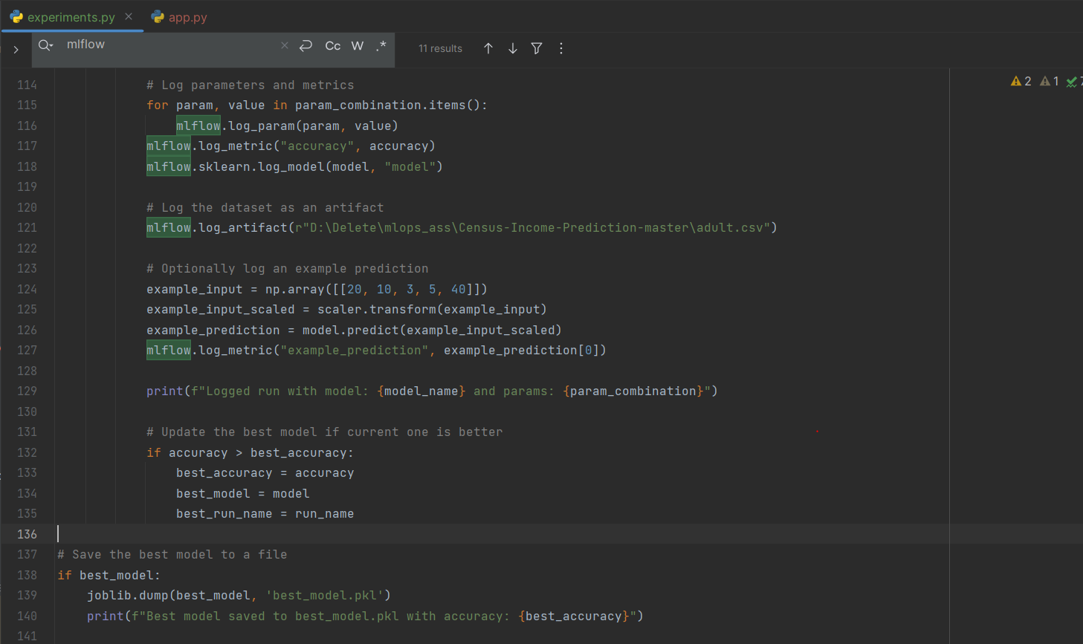

* Defining a grid of hyperparameters for multiple models.
* Generating all possible combinations of these hyperparameters.
* Training and evaluating the models with each combination.
* Logging the results to MLflow.
* Identifying and saving the best-performing model.

2. **Model Packaging**:

• Package the best-performing model using tools like Docker and Flask.

• Create a Dockerfile and a simple Flask application to serve the model.

Flask Application:

1. Code imports, flask application initialization, loading the model

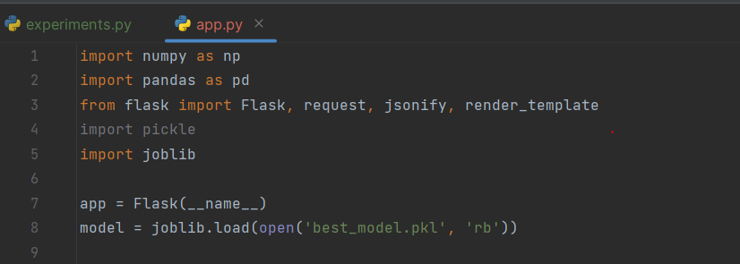

1. Home route, to render html page

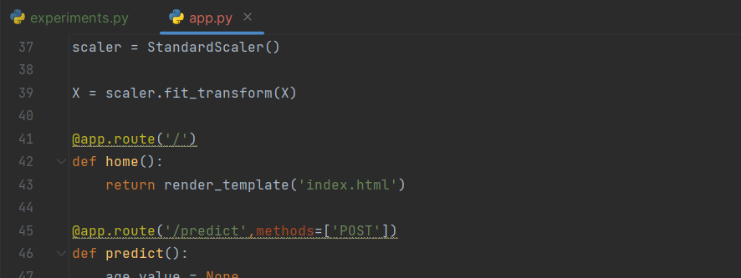

1. Predict route, retrieves the data from given inputs and returns the prediction as JSON

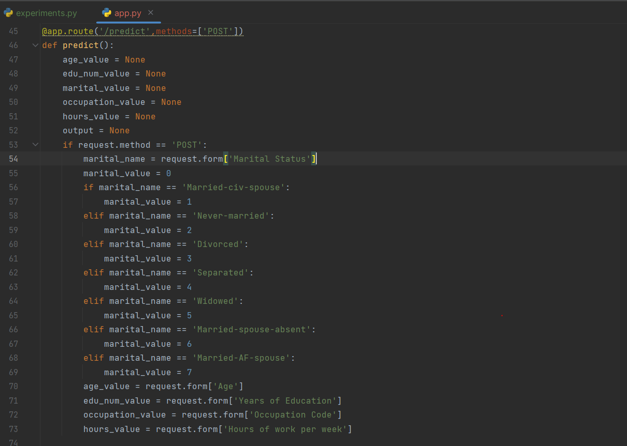

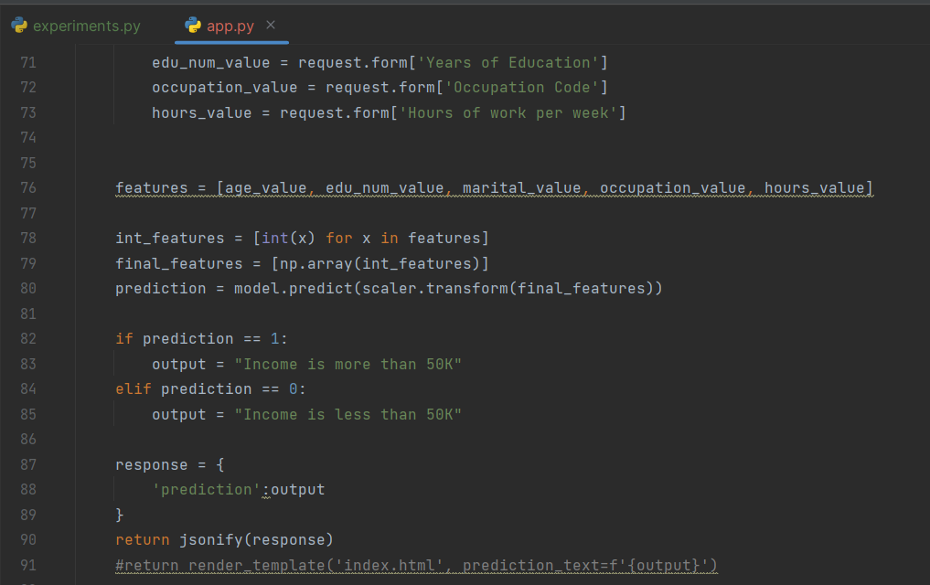

1. When the application is run, we can access it as web application with localhost and port 5000.

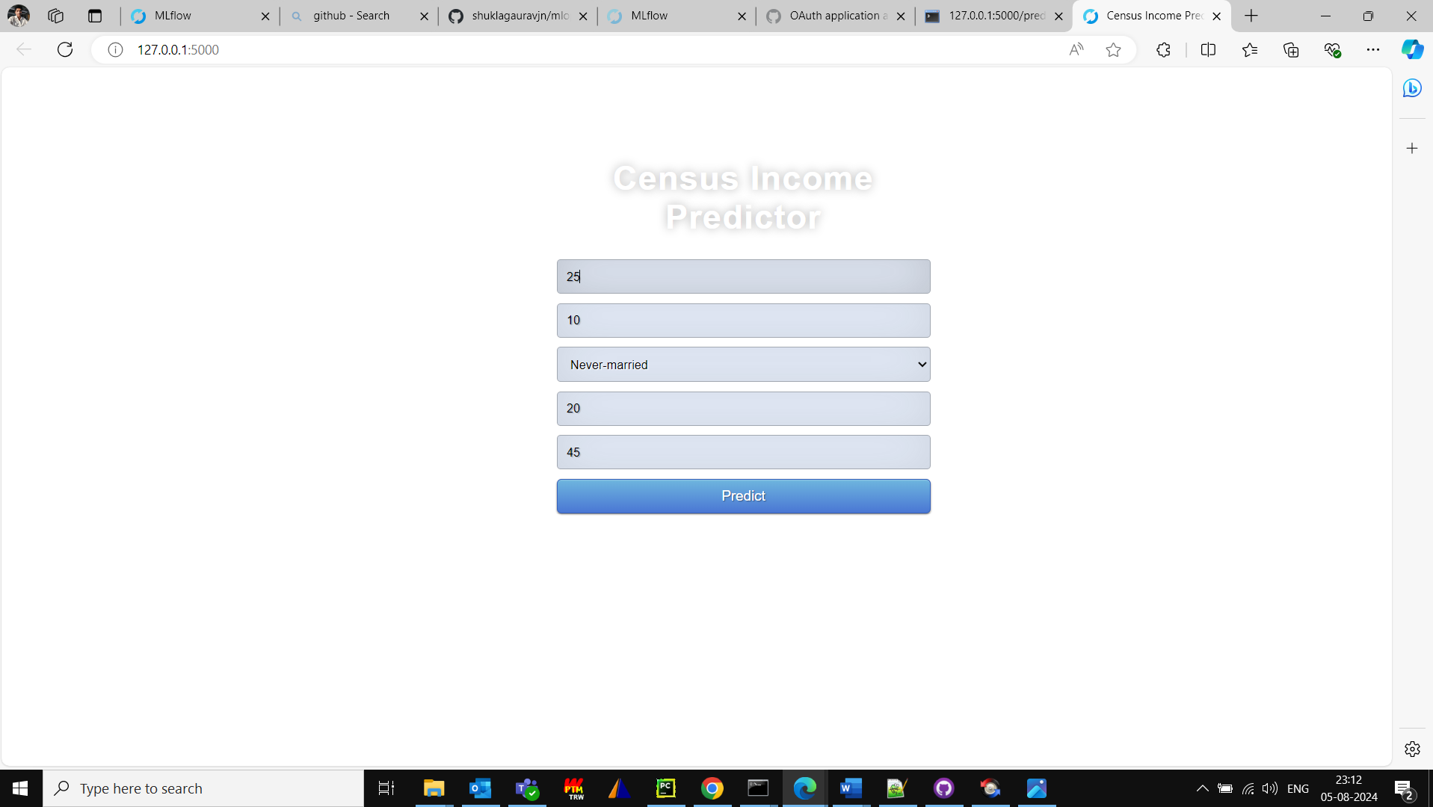

The response after giving the input and clicking on Predict.

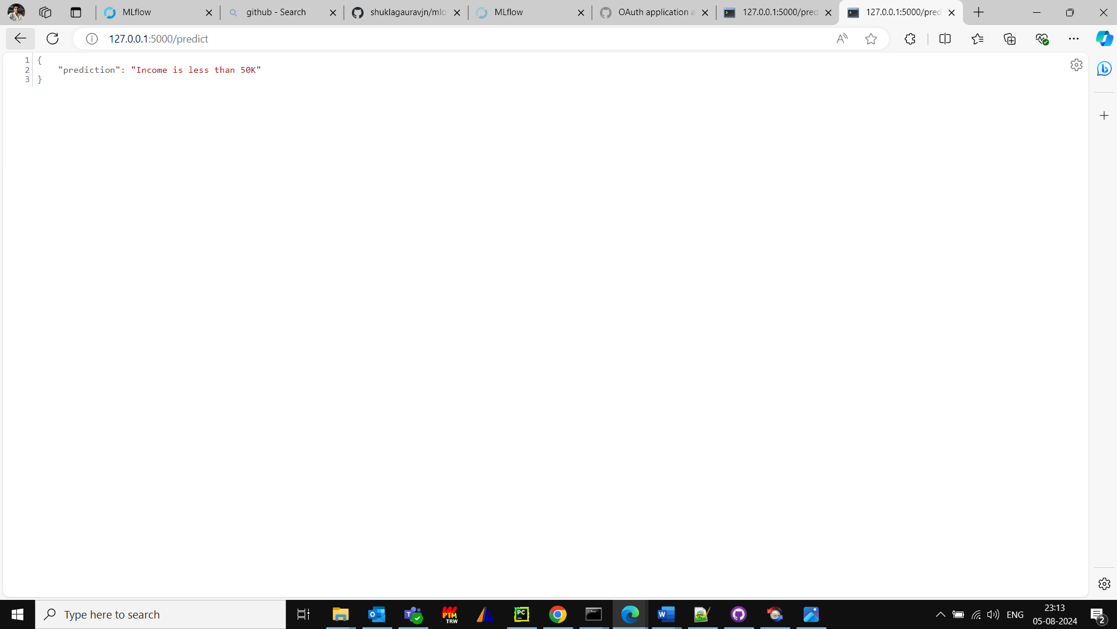

These are the screen shot which shows docker build. In the screen shot below docker build -t shuklagauravjn/ml-ops-group44-v-01:latest .

Leads to building of docker container.

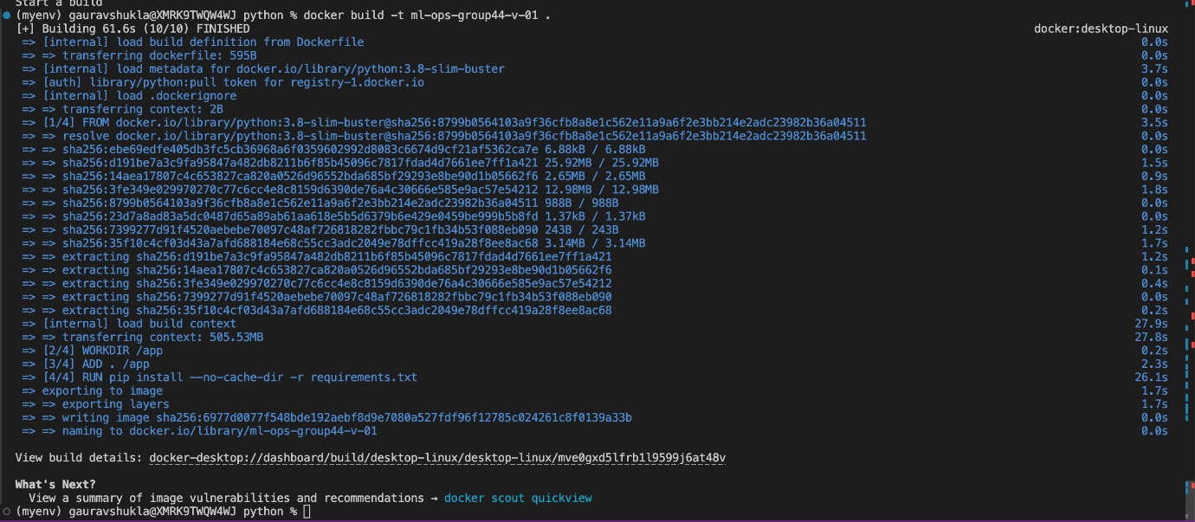

Once the docker container is built, it’s visible in docker desktop on mac.

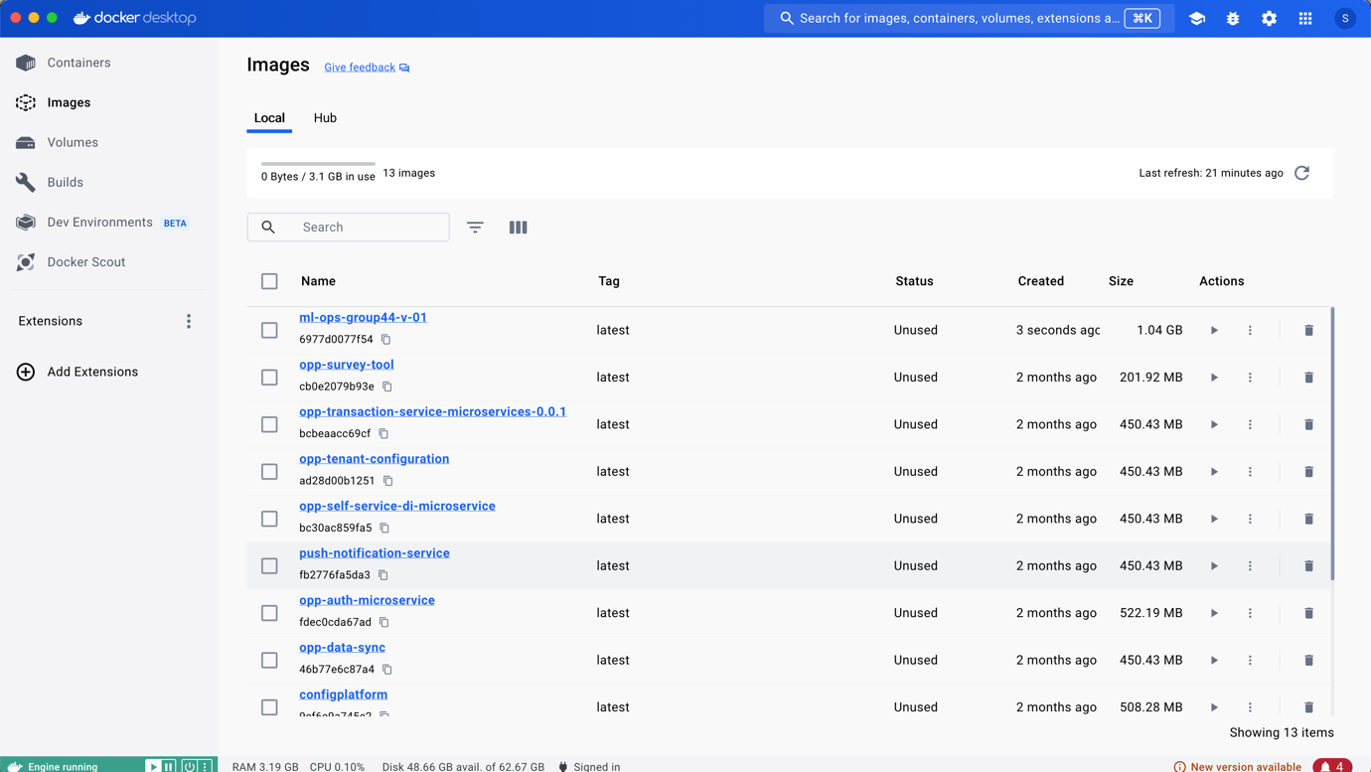

The screen shot below shows the docker image and possible vulnerabilities.

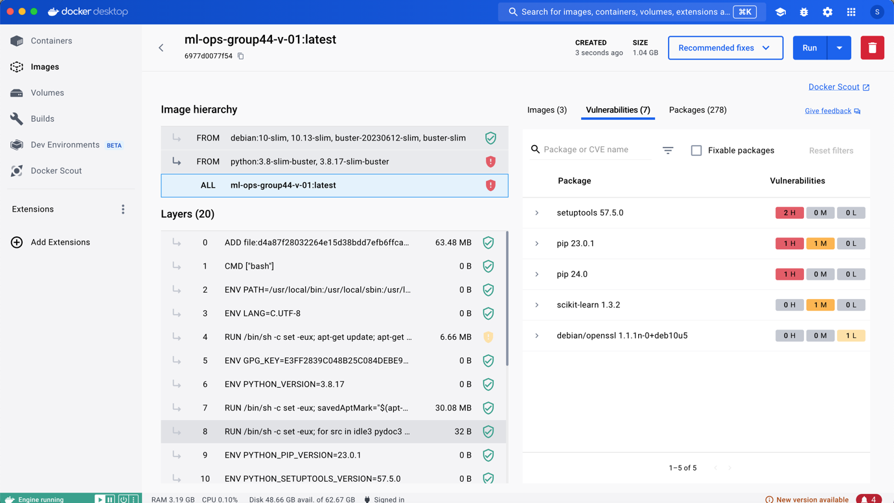

Once the docker container was run from docker desktop, here is the log: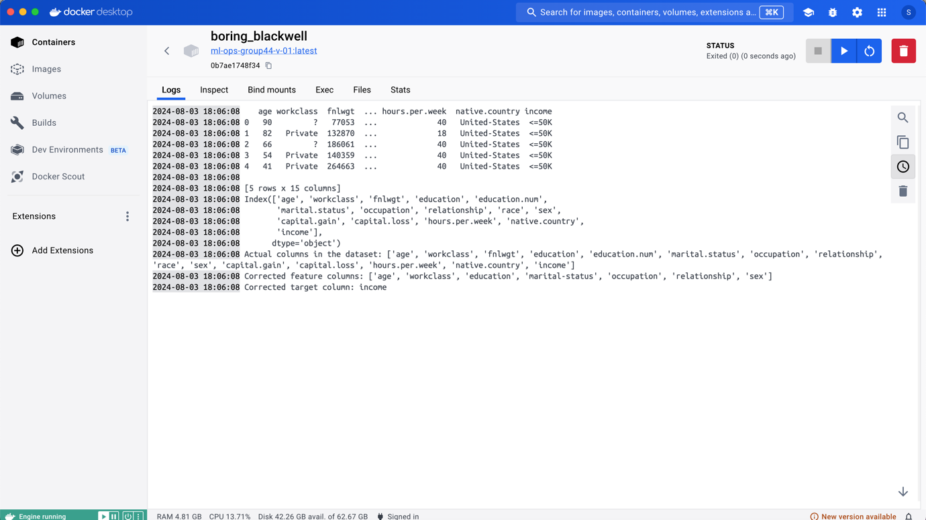

Later this docker image was pushed to docker hub using the following command:

docker login -u "shuklagauravjn" -p "XSDSDwewe#" docker.io

docker push shuklagauravjn/ml-ops-group44-v-01:latest

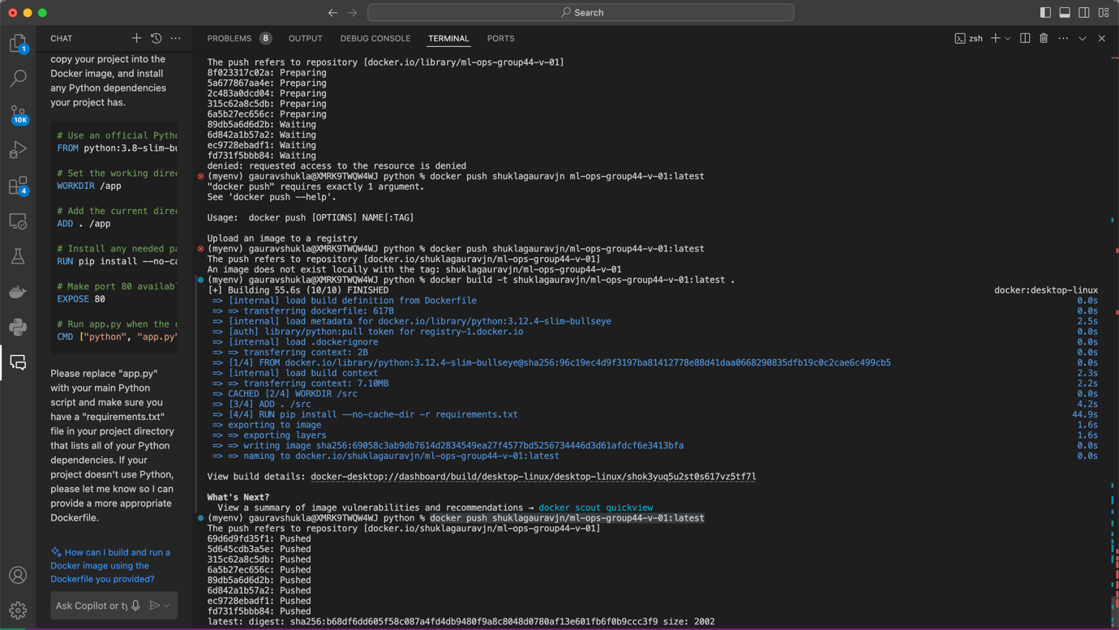

So it can be seen in hub.docker.com

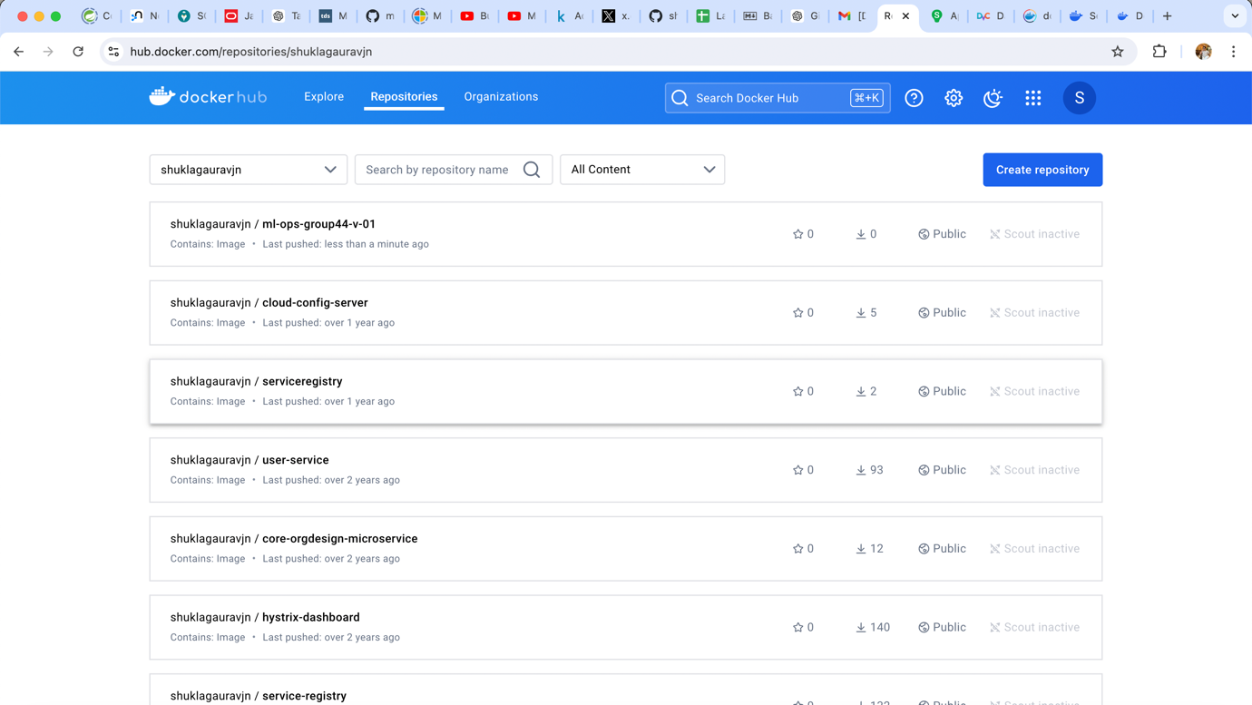

**Deliverables**:

• A report on hyperparameter tuning results.

• A Dockerfile and Flask application code.

• Screenshots of the model running in a Docker container.

**M4: Model Deployment & Orchestration (Optional)**

**Objective**: Deploy a machine learning model and orchestrate its operations using Kubernetes.

**Tasks**:

1. **Model Deployment**:

• Deploy the Dockerized model from M3 to a cloud platform like AWS, Azure, or GCP.

• Use a platform service like AWS ECS, Azure AKS, or Google Kubernetes Engine (GKE).

2. **Orchestration**:

• Set up a Kubernetes cluster.

For local mac following things were done:

brew install minikube

minikube start

kubectl create deployment ml-ops-group44-v-01 --image=shuklagauravjn/ml-ops-group44-v-01:latest

kubectl expose deployment ml-ops-group44-v-01 --type=NodePort --port=8080

kubectl get services ml-ops-group44-v-01

minikube service ml-ops-group44-v-01

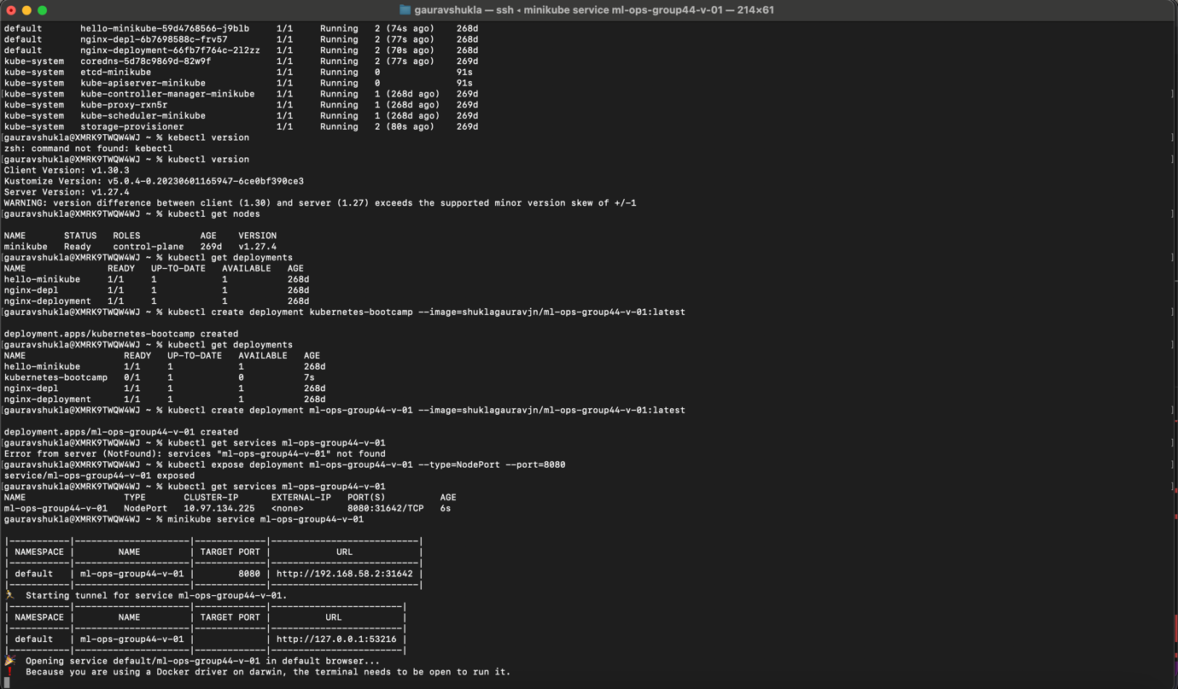

• Deploy the model using Kubernetes and create a Helm chart for managing deployments.

**Deliverables**:

• A link to the deployed model endpoint.

• Kubernetes configuration files and Helm chart.

• A report detailing the deployment and orchestration process.

**M5: Final Deliverables**

• A zip file containing:

• Code

• Data

• Model

• A one-page summary that includes:

• Description of the work completed

• Justification for the choices made

• A screen recording (maximum 5 minutes) that:

* Explains the work done
* Shows the results